Carefully read “Introduction to Flow Cytometry” by Alexis Gonzalez and Vanta Jameson and submit answers to these questions before your face-to-face training session with a Melbourne Cytometry Platform manager

Name:
Student/ Staff:
Supervisor/ Lab/ Affiliation:

Typical tissues/ cells/ particles that you/ your lab work with, for example, haemopoietic, primary neural, cell lines, bacteria, nanoparticles

Typical number of fluorescent colours you (will) work with

- (tick or highlight all the correct option(s)) Flow cytometry analysis provides data that is:
  - Quantitative
  - Qualitative
  - Statistically robust
  - Contains unbiased parameter correlations
  - All the above

- (tick or highlight all the correct option(s)) Flow cytometry can be used to detect particles of the following sizes in the absence of fluorescence label:
  - Single cells from animals and plants
  - Bacteria, yeast and algae
  - Nanoparticles of 20nm
  - Sub-cellular particles such as nuclei
  - Free proteins or antibodies in suspension
  - Nanoparticles including exosomes >100nm
  - Undigested whole organs

- (tick or highlight all the correct option(s)) Which of the following apply to laminar flow?
  - Constant, predictable motion
  - Mixing between parallel layers of fluid
  - Affected by fluid viscosity and velocity, pipe dimensions and physical disruption
  - Non-parabolic velocity profile
  - Affected by samples that have clumps
  - Unaffected by air bubbles

- (tick or highlight all the correct option(s)) Hydrodynamic focusing and sample pressure:
  - Orientates particles lengthwise
  - Forces particles into a single file
  - Accelerates particle velocity
  - Increases particle coincidence as pressure decreases
  - Nanoparticles must be run at the lowest possible sample pressure

- (tick or highlight all the correct option(s)) While running samples in a Cytometer using 488nm FSC signals as an acquisition trigger, which parameter(s) should you view in a 2D plot to best indicate if you have laminar flow conditions/ or to indicate a problem with laminar flow? (Note: the instrument is equipped with violet, blue, yellow/green and red lasers and your fluorescent dyes are primarily excited by all lasers except the violet.
  - Forward scatter versus Side scatter
  - Time versus red or yellow/green laser fluorescence
  - Red or yellow laser fluorescence versus blue laser fluorescence
  - Red or yellow laser fluorescence versus side scatter
  - Time versus blue laser fluorescence parameter
  - All the above

- When preparing your samples, what are the critical treatments to ensure that your samples run stably? (list as many as you can)

- (tick or highlight all the correct option(s)) Voltages or gains amplify the signal output for each scatter and fluorescence photon detector produce and are important for positioning and resolving particle pulses from background and electronic noise. When setting up your experiment on a MCP analyser, voltages or gains must be set:
  - While the sample is running
  - Post-acquisition
  - Either

- (tick or highlight all the correct option(s)) Thresholds can be set for scatter or fluorescence parameters to ‘blind’ the cytometer to measurements that do not achieve a relevant minimum signal (for example, excluding debris). When setting up your experiment on a MCP analyser, the following applies to threshold definition:
  - Must be set while the sample is running
  - Must be set after the adjustment of gains for the triggering parameter
  - Must be set by following its effect on the acquisition of back gated subsets
  - Must be set post-acquisition
  - All the above

- (tick or highlight all the correct option(s)) Compensation is used when 2 or more spectrally overlapping fluorescent molecules are run in an experiment to remove spillover of photons from their non-primary detectors. Which of the following apply when using a MCP analyser:
  - Must be set while the sample is running
  - Must be set using single colour controls samples acquired with the same detector gains
  - Can be set post-acquisition
  - All the above

- (tick or highlight all the correct option(s)) Gating is used to sequentially include (or exclude) subsets or combinations of particles. When setting up your experiment on a MCP analyser, when should gating be set?
  - During the initial instrument setup
  - While the sample is running
  - Post-acquisition
  - All the above

- Select the correct statement(s) using information provided in the histogram and pseudo-colour 2D dot-plot of FSC and SSC measurements of a cell line:
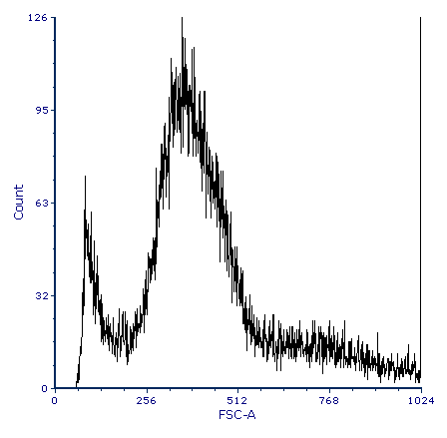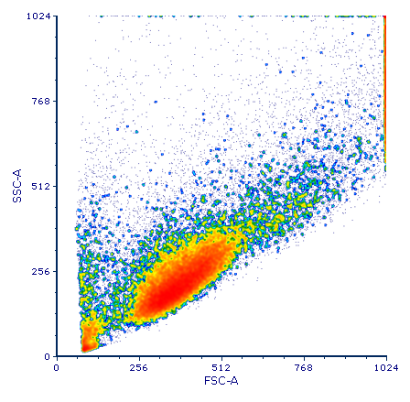

  - Each dot represents 1 event that has passed by the blue laser
  - FSC represents the relative size of the particle
  - SSC represents the complexity of the particle
  - Aggregates of cells cannot be distinguished easily from debris
  - The ellipse surrounds the main population of cells in this sample
  - Particle Scatter is being viewed on a log scale
  - Particle Scatter is being viewed on a linear scale

- What type of optical detection (conventional or spectral) is used by:
- BD FACS or LSR range of cytometers?
- Beckman Coulter CytoFLEX range of cytometers?
- Cytek Aurora range of cytometers?

- Typically, a fluorochrome absorbing one photon from an optimal excitation light source will emit a wavelength _____________ than the photon excitation wavelength (fill in the blank).

- If you need information about the excitation and emission spectra of fluorochromes, where can you find it? (tick or highlight all the correct option(s))
  - Manufacturer’s product sheet
  - Online spectra viewer
  - Primary publication about that fluorochrome
  - Google
  - Flow cytometry staff member
  - All the above

- Give simple examples of how these fluorescent molecules can be used:
  - Fluorescent molecule (such as PECy7) attached to an antibody

  - Fluorescent protein (such as GFP)

  - Dye such as DAPI

- Here is a list of common fluorescent tools used in flow cytometry: (A) Fluorescent proteins, (B) membrane impermeant DNA binding dyes, (C) membrane permeant esterase dyes, (D) fluorophore-conjugated antibodies, (E) amine-binding dyes.
Type A, B, C, D, E beside the following list of particle types to indicate in which fluorescent tools can be detected (there may be more than one answer!):
  - Live cells
  - Unfixed dead cells
  - Fixed/ permeabilized cells
  - Debris

- (tick all that apply) My cells have been transduced with a vector expressing mCherry fluorescent protein with very low expression and I would like to measure the efficiency of transfection via flow cytometry after the cells have been kept in culture for a few days. Select from the list below all the controls you would be the best to use to define your negative boundary?
  - Un-transduced parental cell line
  - Cells in ‘a’ plus a live/dead maker (DNA-binding or amine-binding)
  - Cells transduced with an empty vector (not containing a mCherry construct) and cultured in the same conditions as the transfected cells.
  - Cells in ‘c’ plus a live/dead maker (DNA-binding or amine-binding)
  - Isotype controls
  - Single-colour controls (for compensation or unmixing)
  - Fluorescence minus one controls
  - Biological controls

- (tick all that apply) I have a sample of lung tissue from a wild-type mouse that I would like to analyse for different leukocyte subsets. I’ve stained my sample with 15 fluorescence conjugated antibodies, and some of my markers are very dim. I need the following controls:
  - Unstained lung tissue
  - Unstained lung tissue with a live/dead maker (DNA-binding or amine-binding)
  - Isotype controls
  - Single-colour controls (for compensation or unmixing)
  - Fluorescence minus one controls
  - Biological controls

- (tick all that apply and specify expand where required) I am comparing the amount of intracellular cytokine expressed by stimulated and unstimulated dendritic cells enriched from peripheral blood. I need to identify my DCs by doing cell-surface staining and fix and permeabilise my cells to detect the intracellular marker. In total, I am going to need 8 fluorescent-labelled antibodies. I need the following controls:
  - Unstained DCs – which ones?
  - Live/dead marker (specify which type)
  - Isotype controls (if so, why?)
  - Single-colour controls (for compensation or unmixing)
  - Fluorescence minus one controls
  - Biological controls (specify which ones)

- (tick all that apply and specify/ expand where required) I am investigating the role that my gene of interest plays as pluripotent cells differentiate into neural cells. I have introduced a GFP construct by homologous recombination into the endogenous promoter, thus producing a partial knockout of my gene in embryonic stem cells. As I stimulate my cells to differentiate toward neural cells, I predict that GFP will be switched on as the endogenous promoter is activated. The experiment is a time-course experiment and I don’t know at which day of differentiation I should expect the GFP to signal. For each timepoint in my experiment, I need the following controls:
  - Parental cell-line differentiated the same as my GFP line.
  - Live/dead marker (specify which type)
  - Isotype controls
  - Single-colour controls (for compensation or unmixing)
  - Fluorescence minus one controls
  - Biological controls

- I am planning an experiment to define the cellular distribution of a rare tdTomato Fluorescent protein-tagged cellular receptor which is suspected to play a role in immune responses in mice. As part of the analysis that will be done in instrument A (see optical layout below), you’ll have the possibility to use antibody conjugates against markers of interest that are already available in your lab. These are coupled to the following dyes: BUV395, BUV496, BUV737, BV421, BV510, Pacific Blue, BV610, BV650, BV785, FITC, PerCP, BB515, PE, APC, Alexa Fluor 647, APC-R700 and Alexa Fluor 700.
  - Which one of these conjugated antibodies cannot be used in your experiment and why?
  - Which other conjugated antibody will not be suitable for this specific experiment and why? (consider the entire experiment)
  - Which of these dyes cannot be used simultaneously in your panel? (Select all dyes that apply).
  - Assign in addition to tdTomato, all the dyes that could be used in your experiment to the corresponding detectors in an instrument A with the following configuration:
 | Instrument A
Laser | Bandpass filter | Fluorochromes?
355 nm UV | 405/30
 | 525/40
 | 740/35
405 nm violet | 405/10
 | 450/45
 | 525/40
 | 660/10
 | 763/43
 | 525/40
488 nm blue | 610/20
 | 690/50
561 nm yellow-green | 585/42
 | 610/20
 | 675/30
 | 710/50
 | 763/43
 | 660/10
640 nm red | 712/25
 | 763/43
808 nm IR | 840/20
 | 885/40

