

—

**Research Platform Booking System**

Quick Reference Guide

iLab

For Principle Investigators

15 September 2020

Table of Contents

Register for an account and lab group in iLab 3

University of Melbourne Principal Investigator (PI) 4

External PI from an Institution Integrated with iLab 4

External PI Account and Lab Group Registration 5

Sign-in to iLab 8

UoM Single Sign On (SSO) 9

External Sign In 9

Navigating UoM Research Platform iLab Cores 11

Navigating UoM Research Platform iLab Cores 12

Manage Your Research Group in iLab 13

Overview 14

Adding New Lab Members 15

Assigning Lab Managers and Core Financial Contacts 16

Assigning Themis Account Strings to Lab Members 18

Adding New Themis Account Strings for your UoM Lab Group 19

Hiding Unnecessary Account Strings in your Lab Group 19

Support 20

Support 21

Access the iLab Support Portal 21

Register for an account and lab group in iLab

University of Melbourne PI

External PI from an Institution Integrated with iLab

External PI Account and Lab Group Registration

## University of Melbourne Principal Investigator (PI)

**Most University of Melbourne PIs will automatically have a lab group created for them** in the iLab system based on research project account codes. For most PIs this should mean they can immediately go to the Sign-In process and access their account and lab group.

If you are a UoM PI that has not had a lab group automatically created, one can be manually created for you by the UoM Admin or the RPBS project team (RPBSproject-team@unimelb.edu.au).

## External PI from an Institution Integrated with iLab

If you are a PI from an institution that is external to the University of Melbourne but that already has iLab implemented, such as Monash University, to get started you must register for an iLab account through your institution’s sign in page.

Navigate either to your institution’s iLab page or the Research Platform’s Core page:  
https://unimelb.ilab.agilent.com/

1. Hover over the word ‘Register’ and select the ‘Register for an iLab account’ option

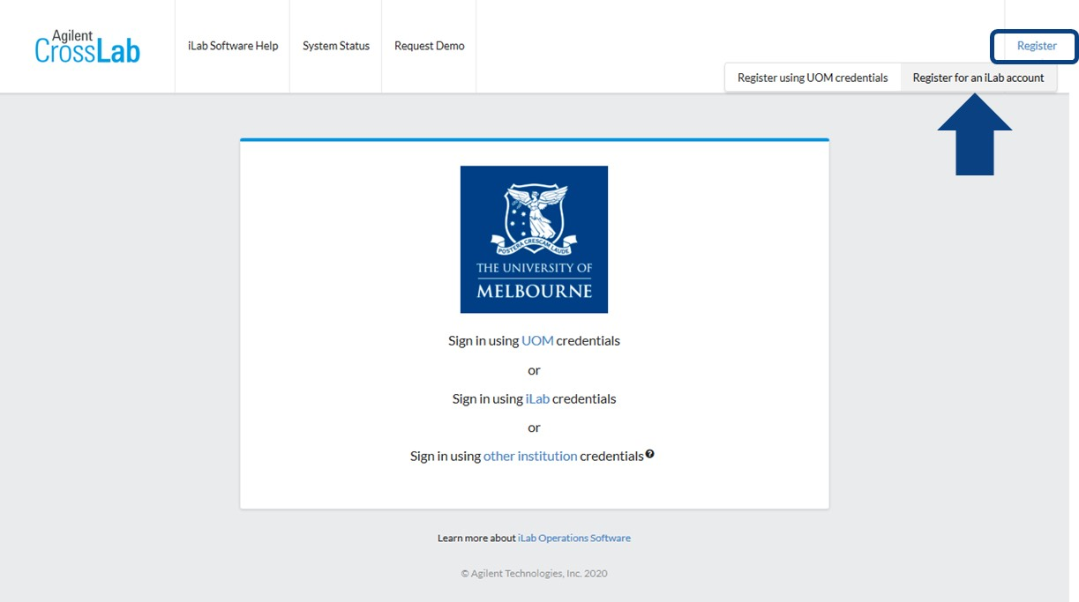

1. Enter your institution email address into the registration form that appears and click ‘**Continue’**

A pop-up will appear informing you that your institution is already integrated with iLab.

1. Click ‘**Continue**’

Your browser will be redirected to your institutions iLab sign-in page

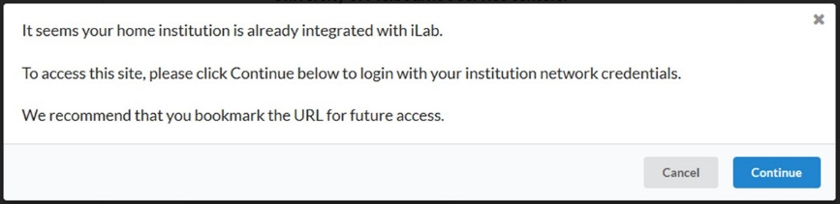

1. Follow your institution’s registration process
2. For support please contact your local iLab integration or IT support team

## External PI Account and Lab Group Registration

If you are a PI that is external to the University of Melbourne (and not from an institution that already has iLab implemented, such as Monash University), to get started you must register for an external iLab account, and request for a new lab group to be created in your name

Navigate to either the University iLab page or the Research Platform’s Core page:  
https://unimelb.ilab.agilent.com/

1. Hover over the word ‘Register’ and select the ‘**Register for an iLab account**’ option

You will be presented with a multi-step registration form to complete.



1. Enter your institution email address and click ‘**Continue**’.

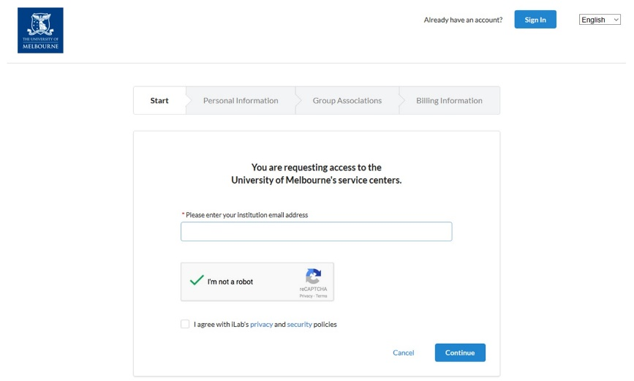

1. Complete the mandatory fields indicated by a red asterisk and click ‘**Continue**’

If your affiliation does not exist for selection, enter the full correct name of your institution/workplace and select the ‘create new’ option.

Example: ✓ University of Melbourne  
🗶 UoM  
🗶 Melbourne University

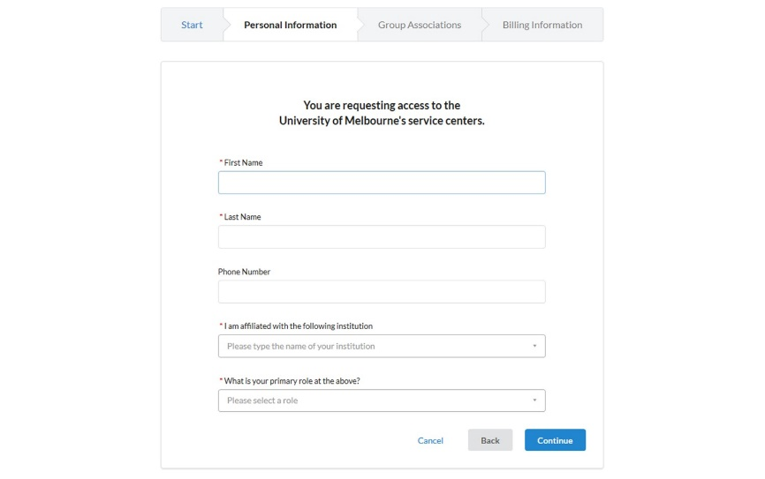

1. Assuming that your lab group is not already registered in the system, on the Group Associations section select the ‘**Create New Group**’ option.
2. Complete the mandatory fields indicated by a red asterisk and click ‘**Continue**’.  
   **Do not change the auto-generated group name.**

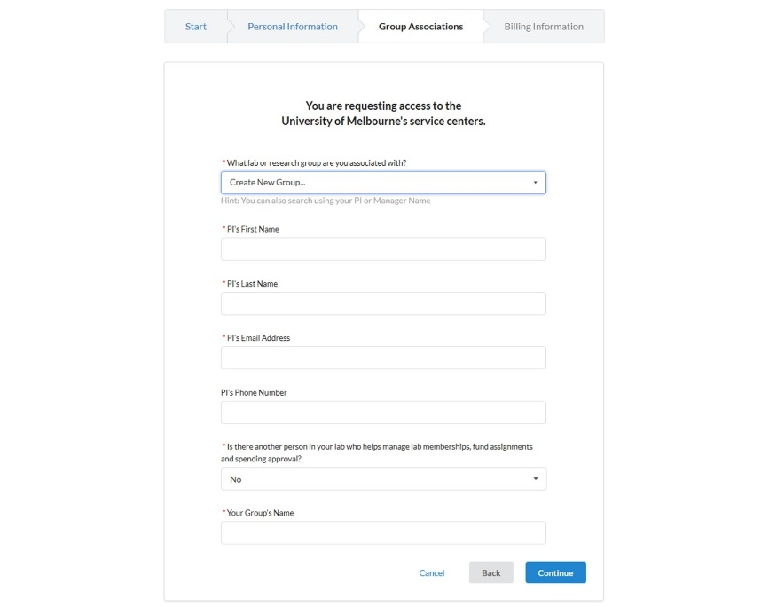

1. Enter the billing address for your institution/lab group. Add extra fields to the form, such as Institution and Department, by clicking the prompts on the right side of the form.

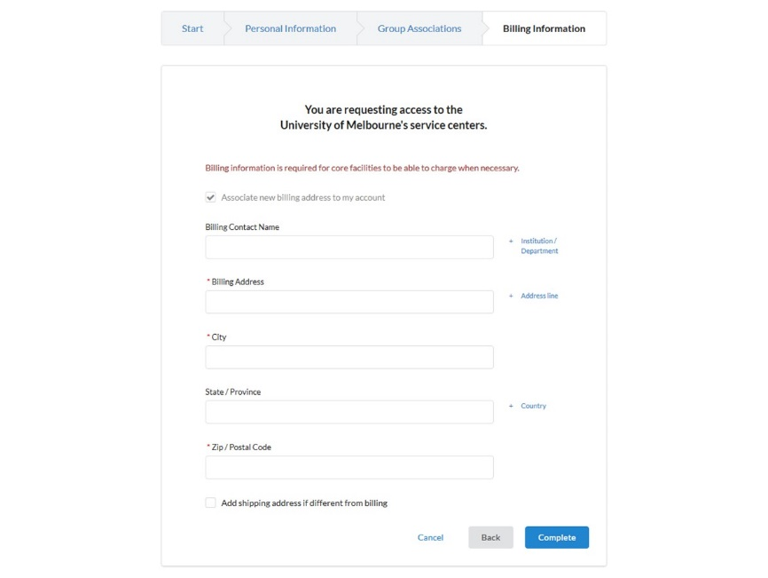

1. Click ‘**Complete’**

Please allow 2 business days for your account to be created. You will receive a Welcome Email from iLab with your login credentials.

Sign-in to iLab

UoM Single Sign On (SSO)

External Sign In

Requesting Access to Multiple Lab Groups

## UoM Single Sign On (SSO)

University of Melbourne researchers can sign-in to iLab via the UoM SSO portal.

1. Navigate to the Research Platform’s Core page,
2. On the upper-right-hand corner of the screen click ‘**Sign In**’

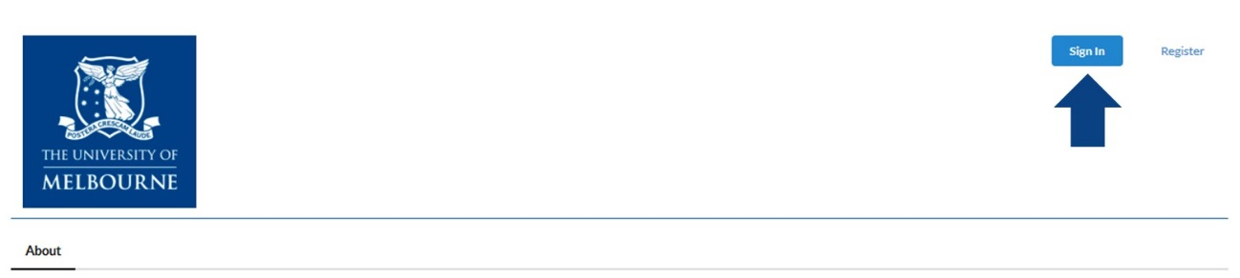

1. Click ‘**Sign in using UOM credentials**’

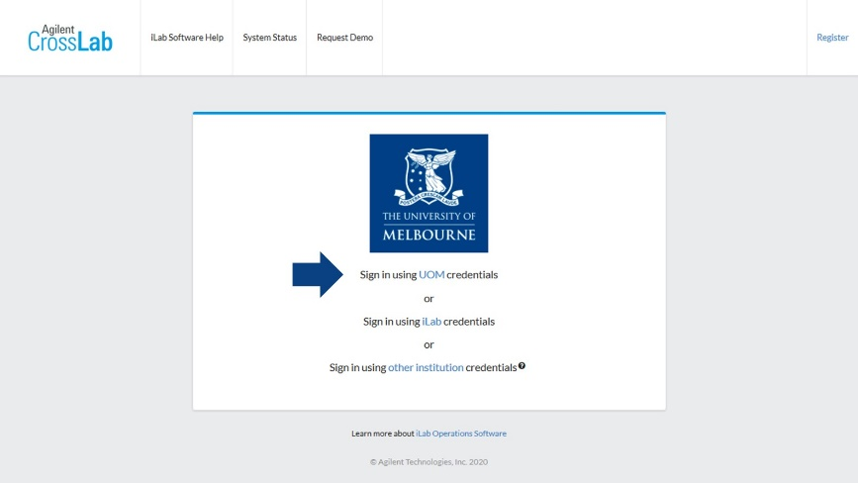

1. You will be taken to the University’s SSO portal to input your credentials. Note that multi-factor authentication (MFA) is also active so you may be prompted to also authenticate via Okta

## External Sign In

**External researchers from an institution *with* an iLab integration** will sign in via their institution login page.

Navigate to the Research Platform’s Core page,

1. Click ‘**Sign in using other institution credentials**’

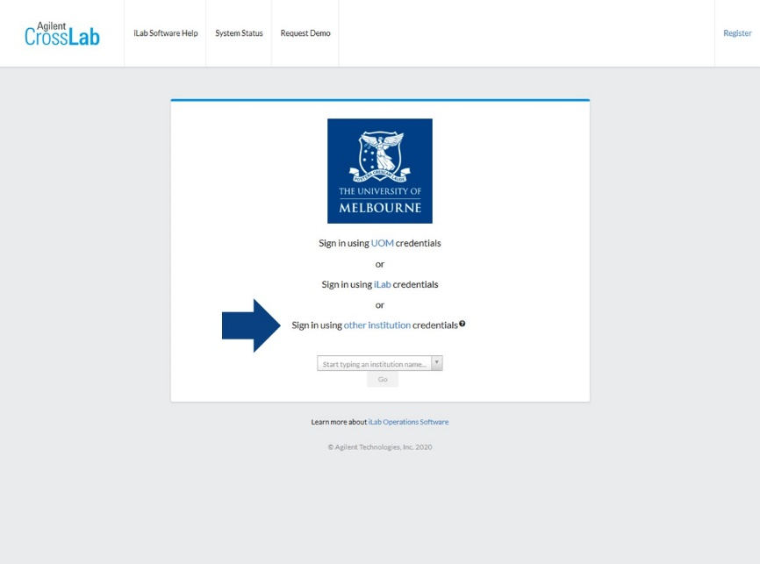

1. In the new field that appears start typing your institution name and select it when it is found.
2. Click ‘**Go**’ and you will be redirected to your institution’s iLab sign-on page
3. When you sign in through your institution you will be redirected back to the UoM Research Platform’s Core

**External researchers from an institution *without* iLab integration** should sign in with their iLab credentials.

Navigate to the Research Platform’s Core page,

1. On the upper-right-hand corner of the screen click ‘**Sign In**’



1. Click ‘**Sign in using iLab credentials**’ and input your login details

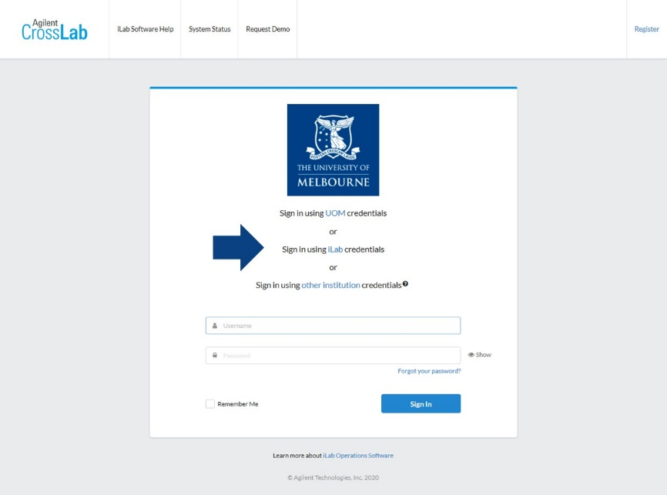

Navigating UoM Research Platform iLab Cores

## Navigating UoM Research Platform iLab Cores

Agilent iLab has a consistent general appearance across all UoM Research Platforms with most end-user operations accessed via the row of tabs near the top of the page.

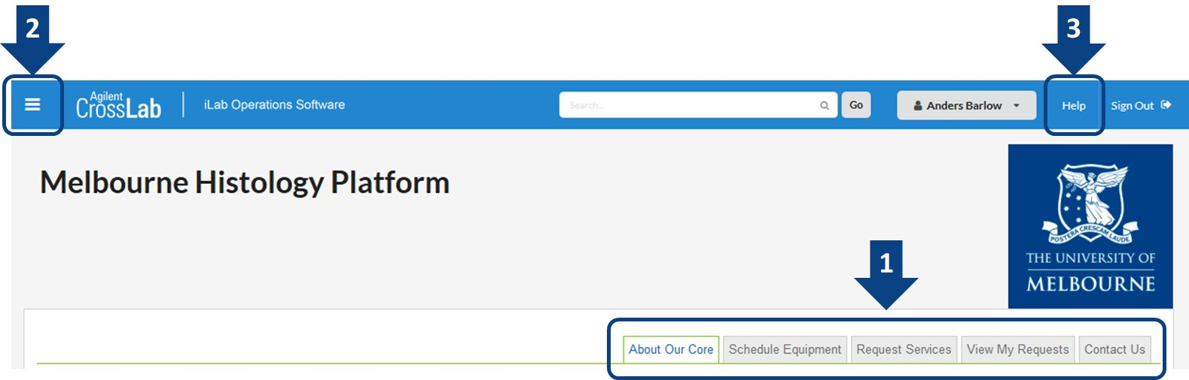

**1 – Navigation tabs**

* **About Our Core** – An overview of the platform’s research capability, services and resources, as well as contact information for the platform leadership and staff
* **Schedule Equipment** – Access the research platform’s resources including requesting training on specific resources, viewing resource schedules and booking time on permitted resources
* **Request Services** – Access the research platform’s services including general service/training requests, and specific services offered by the platform
* **View My Requests** – View requests that you have already submitted to the platform
* **Contact Us** – Submit a comment or question to the platform staff

**2 – ‘Hamburger icon’ left-hand pop-out menu**

* **Home** – Access service requests, messages, your cores and institutions, and all features available in the left and top navigation panels
* **Core Facilities‍** – List and search all core facilities‍ at your own institution, as well as at partner institutions and other outside institutions
* **My Groups** – Manage your iLab group

**3 – Help**

* Access to iLab's support dashboard which provides help documentation, webinars, and access to the support portal to submit support tickets with Agilent (the system vendor)

Manage Your Research Group in iLab

Overview

Adding New Lab Members

Assigning Lab Managers and Core Financial Contacts

Assigning Themis Account Strings to Lab Members

Adding New Themis Account Strings for your UoM Lab Group

Hiding Unnecessary Account Strings in your Lab Group

## Overview

To access your Lab Group interface, first sign-in to iLab, then,

1. Locate the left-side pop-out menu by clicking on the top-left ‘hamburger icon’
2. Hover over ‘**My Groups**’ and click on your group name
   1. Alternatively, you can click on ‘**My Groups**’, then click on your group name in the new window

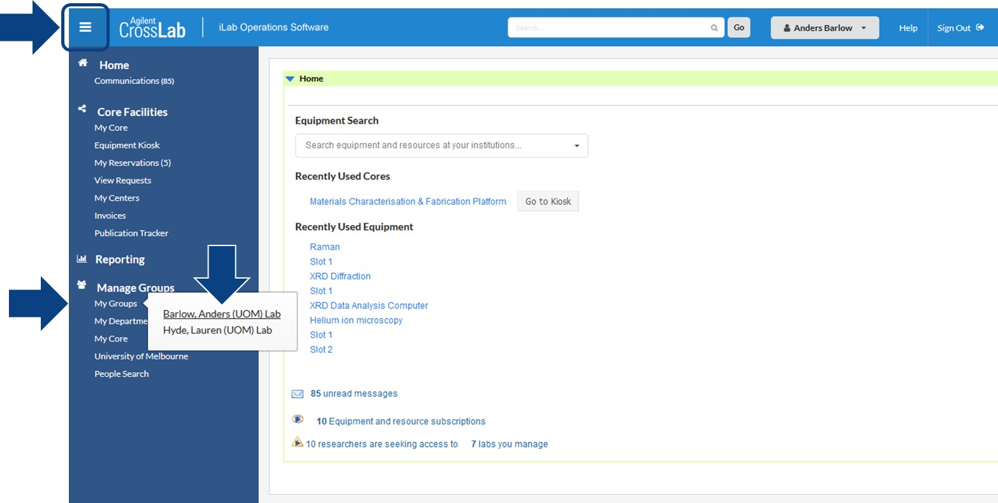

1. You will now see your lab group interface which will allow you to manage your group in iLab

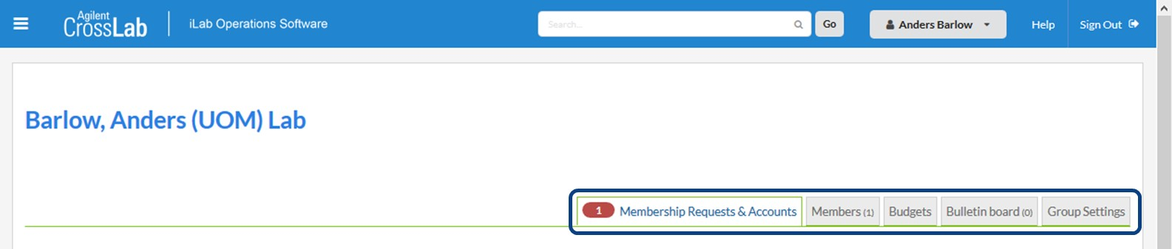

* **Membership Requests & Accounts** – Here you will approve requests to add new members to your group and assign Themis account strings to your lab members. Note that a notification on this tab such as a number in a red shape indicates requests that require attention.
* **Members** – Manage your existing group members and assign roles such as ‘lab manager’ and ‘financial contact’, and link existing registered iLab users into your lab
* **Budgets** – Setup per-member or per-Core spending budgets, and set up alerts for spending thresholds
* **Bulletin Boards** – Communicate within your lab group
* **Group Settings** – Various settings including setting a lab group primary contact

## Adding New Lab Members

There are two ways for new members to be added to your lab group: via a request from the user, or by linking existing users into your lab directly.

**Approving lab group access requests from users:**

When you sign-in to iLab and navigate to your lab group, any pending access requests will be indicated in the ‘Membership Requests & Accounts’ tab and highlighted by a notification icon

1. Click on the ‘**Membership Requests & Accounts**’ tab
2. Pending requests will appear under the Membership Requests section, to accept a member into your lab click the ‘**Accept**’ button

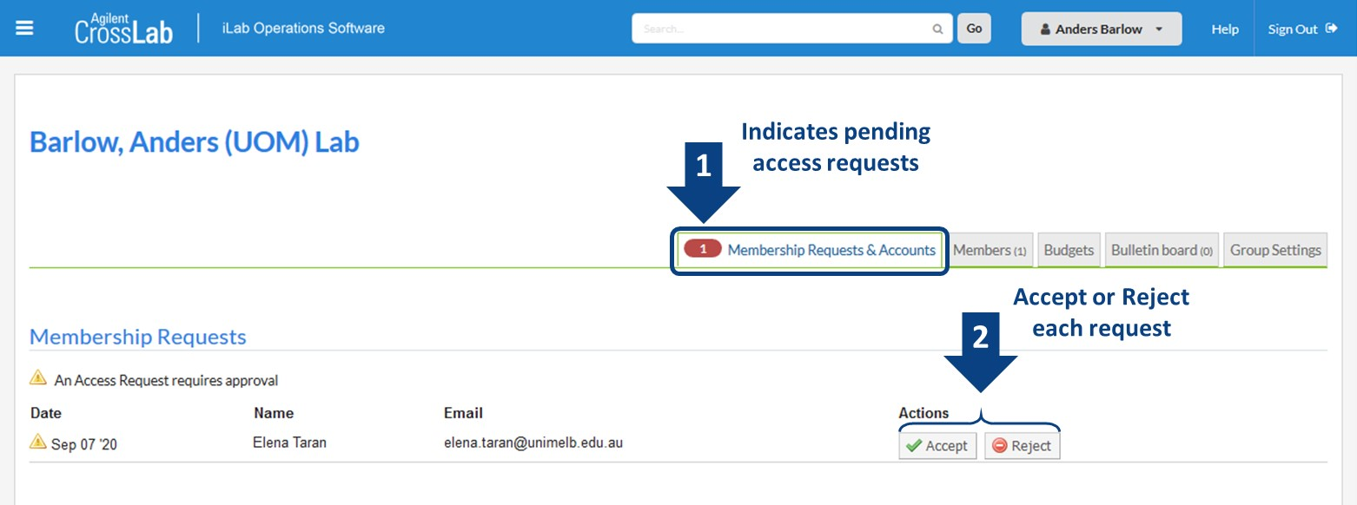

**Link existing users to your lab:**

You can manually link an existing registered iLab user to your lab group

1. Click on the ‘**Members**’ tab
2. Under the Lab members and settings section click on the ‘**Link Existing User**’ button
3. Type the user’s name into the search box that appears, the system will automatically search for the user, click on their name in the list that appears
   1. Choose an appropriate role for the user: member, manager, or principal investigator
   2. If you wish you may add start and end dates for the user
      1. Start Date: The start date for the user as a member of the lab. If set in the future the user will not be associated with the lab until the start date. If empty, the user will be active immediately.
      2. End Date: The end date for the user as a member of the lab. After this date the user will be removed from the lab and will not be allowed to pay for services lab accounts. If empty, the membership will have an indefinite duration.
   3. You can leave ‘Can order?’ unchecked
4. Click ‘**Invite**’

The user will now appear in your members list

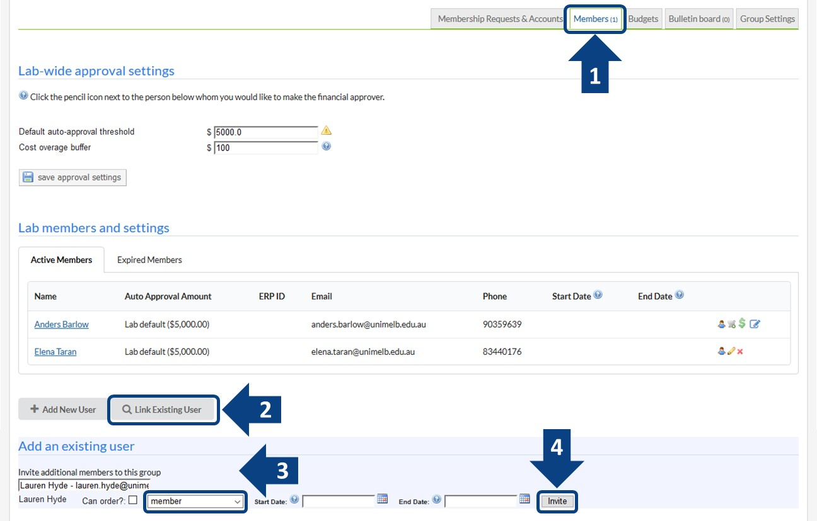

## Assigning Lab Managers and Core Financial Contacts

You may wish to delegate responsibility to a lab member by assigning them as a lab manager and/or financial contact

1. Click on the ‘**Members**’ tab and locate the lab members section
2. Find the lab member you wish to delegate responsibility to and click the ‘**blue pencil icon**’ to the right

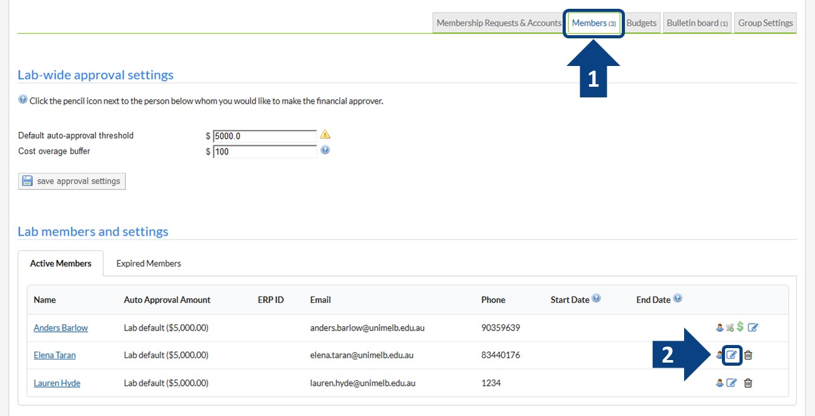

1. On the new window that appears set the Permission to ‘**manager**’, this grants the user similar rights to the PI role, allowing them to approve new members and manage existing members
2. If you wish to also delegate communication to the lab manager, check the ‘**Core Financial Contact**’ box, all iLab notifications for the Lab Group will be sent to this user
3. Click ‘**Save**’

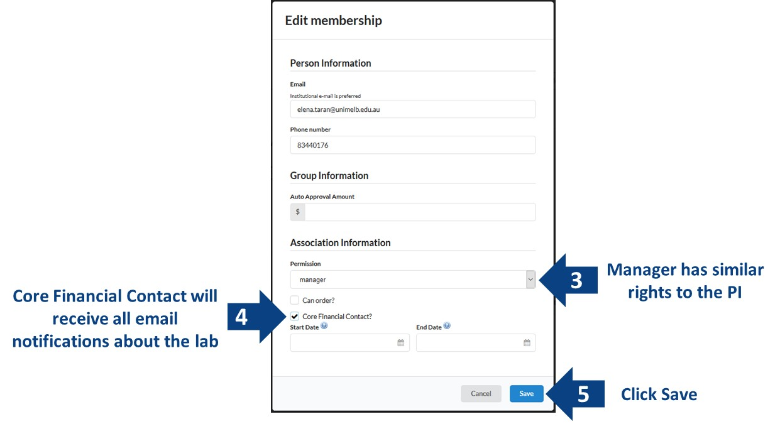

1. You will now see that the green ‘**$**’ symbol has moved to the assigned lab member and that their role icon has changed from blue to yellow, indicating they are now the Core Financial Contact and a Lab Manager  
   (you may need to refresh your page to see these changes)

Notes: i. You can have multiple Lab Managers  
ii. There is only one Core Financial Contact

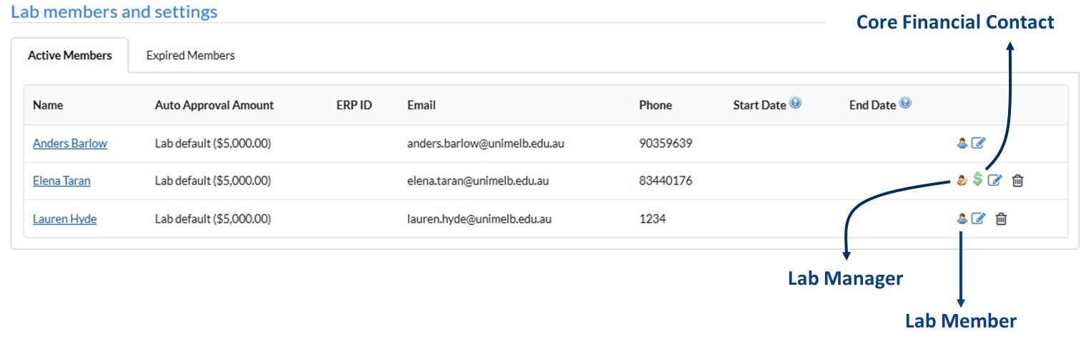

**If you delegate the Core Financial Contact to another lab member you as the PI will no longer receive notifications about your lab group, and the newly assigned lab manager will be able to approve new member and assign financial information.**

## Assigning Themis Account Strings to Lab Members

**Any lab member from a UoM Lab Group** **must have an active Themis account string assigned** to them in order to access Research Platform resources and services.

**Lab members from External Lab Groups** may be able to access Research Platform resources and services without assigned payment information, however some Platforms may require Purchase Order numbers.

**Lab members from iLab-Integrated External Lab Groups should follow the requirements of their own institution**.

To assign Themis account strings to lab members,

1. Click on the ‘**Membership Requests & Accounts**’ tab
2. In the Manage Accounts section you will find the ‘**accounts grid**’ for your lab group

Note: For UoM PIs, account strings are automatically added to your lab group upon creation of the lab

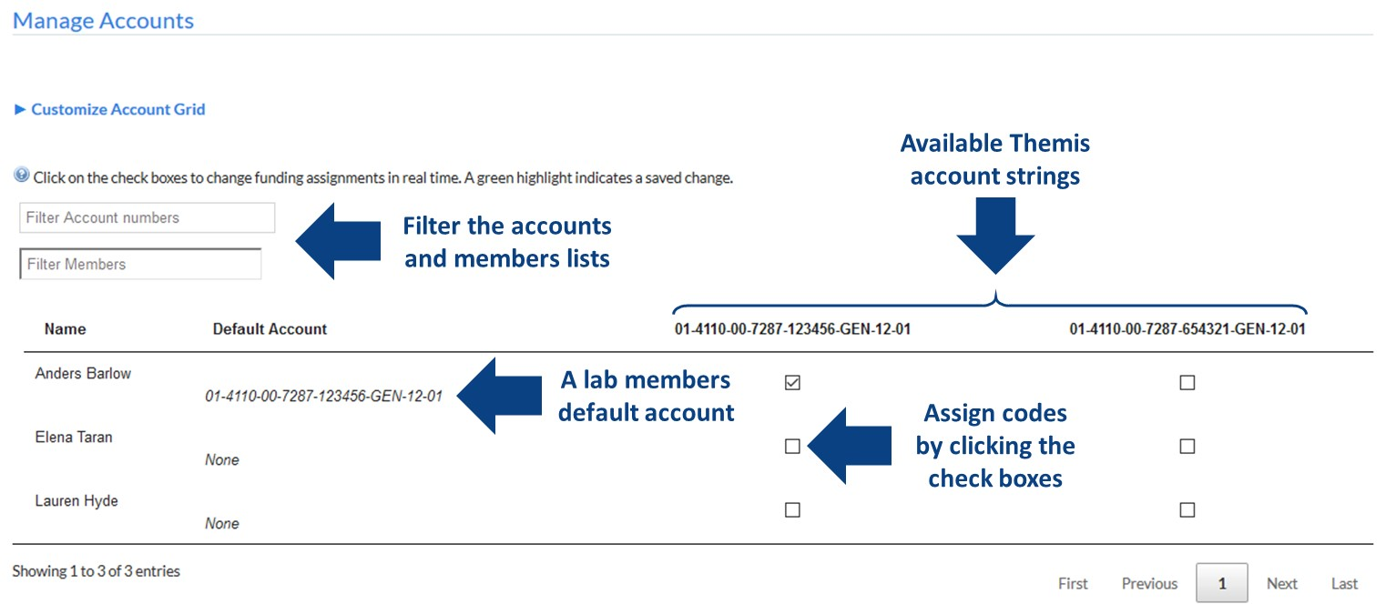

1. To make an account available for a member to use, simply click the check box of the account in the row of the member you wish to assign it to, users can have multiple accounts assigned to them for use
2. To set a default account that will automatically be selected when the user accesses a Research Platform, click the text in the Default Account column for the lab member, you can then select a default account from the accounts that have been assigned
3. Account assignments are immediate, you do not need to ‘save’ them, recent changes are highlighted in green

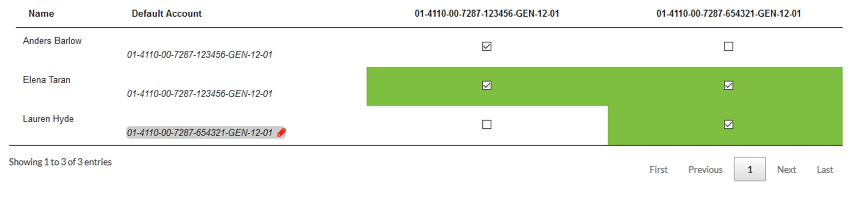

## Adding New Themis Account Strings for your UoM Lab Group

UoM PIs will automatically have a lab group created for them based on research project account codes and this will determine the available Themis account strings for an automatically generated lab group. There may be cases where a desired Themis account string has not been included in a lab group (such as operational funds), and these can be manually added by the PI of a lab group or by Platform Managers.

If you are uncertain about adding a new Themis account string please talk to the Platform Manager or the RPBS project team (RPBSproject-team@unimelb.edu.au).

To add a new Themis Account string, click on the ‘**Membership Requests & Accounts**’ tab,

1. Navigate down to the ‘Manually add a new Account’ section (you may need to expand this section) and complete the fields ensuring that each segment of the string is entered correctly  
   **Note: it is difficult to correct erroneous Account strings once they are used, ensure that they are entered correctly first**
2. Click ‘**Add**’

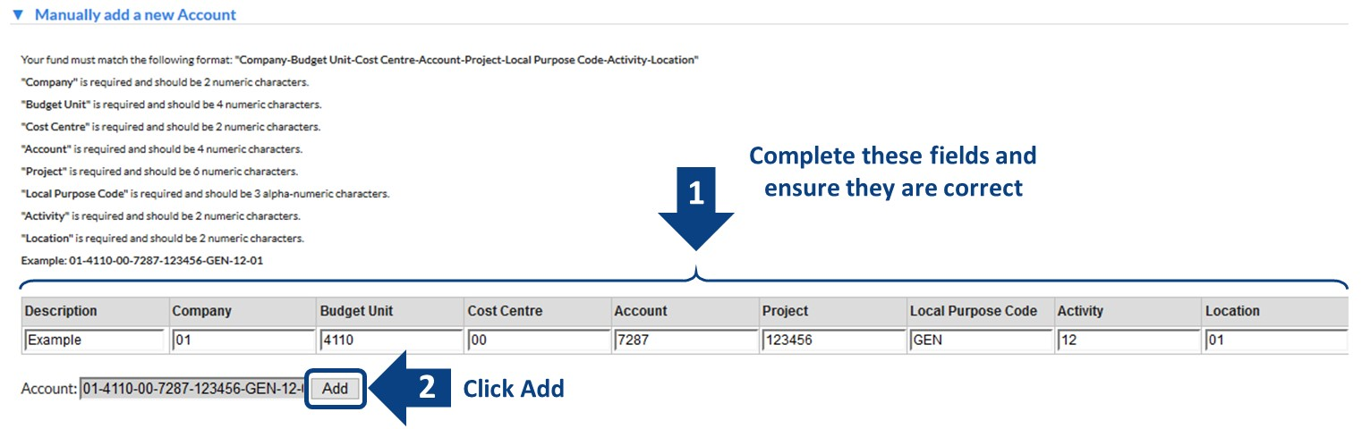

The new Themis Account string will appear in your accounts grid to be assigned to lab members.

## Hiding Unnecessary Account Strings in your Lab Group

You can hide account strings from your accounts grid so they cannot be assigned to lab members. By hiding accounts instead of deleting them you will maintain them as part of your lab group for future reference.  
Note: if you delete an account from your lab group that was automatically imported by the system you will likely find the account will again be automatically assigned to your lab group.

To hide account strings from your accounts grid,

1. Click on the ‘**Membership Requests & Accounts**’ tab and navigate to the bottom of the page where you will find the ‘Manage Accounts’ section (you may need to expand this section)
2. Find the account string you wish to hide in the list, then click the text in the **Status column** to activate a pull-down menu, and change the status to ‘**hidden**’

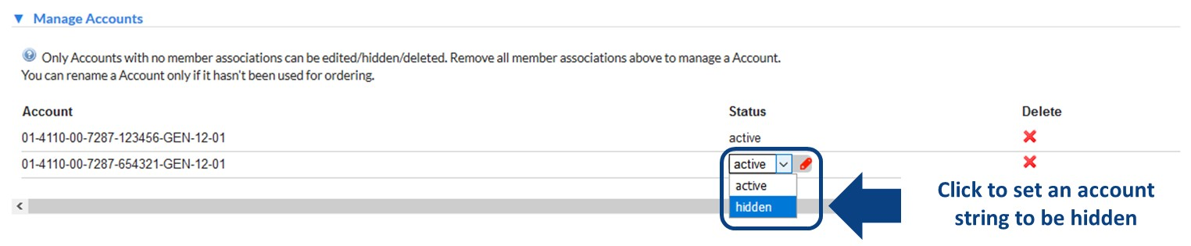

1. Reload the page and you will see that the account string has been removed from your accounts grid

Support

## Support

**For UoM SSO login issues**, UoM researchers should contact the IT Service Centre on +61 3 834 40888/40999 or via the University Services Portal.

**For external researcher login issues**, researchers should contact your institution’s IT Support if your institution has an iLab integration or contact iLab directly at iLab-support@agilent.com if your institution is not on iLab.

**For any resource, service or platform-specific support**, your first contact should be with the platform management staff. Contact information for the platform will generally be included on the ‘About Our Core’ tab.

**For support with financial payment information** PIs should contact the Platform Managers for support with Themis Account strings.

**For simple or general iLab support** and “How do I…?” type questions, talk to platform support staff who will be able to assist you with frequently asked questions.

**For more in-depth iLab support** read through the Help documentation on the iLab support portal.

## Access the iLab Support Portal

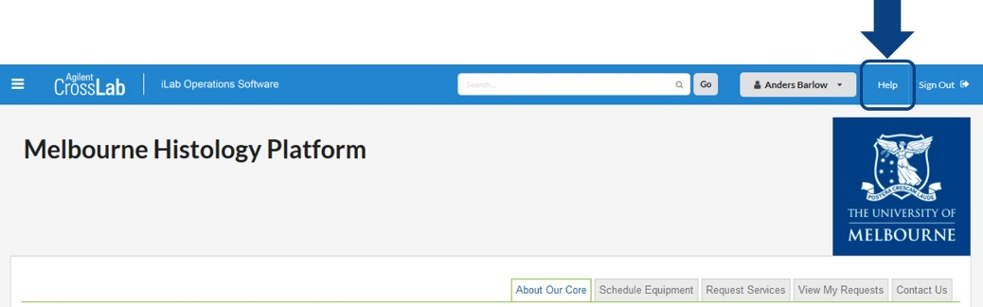

From any core page you will be able to access the iLab Help Portal by clicking the ‘Help’ button in the top-right of the page. This will open the portal in a new window.

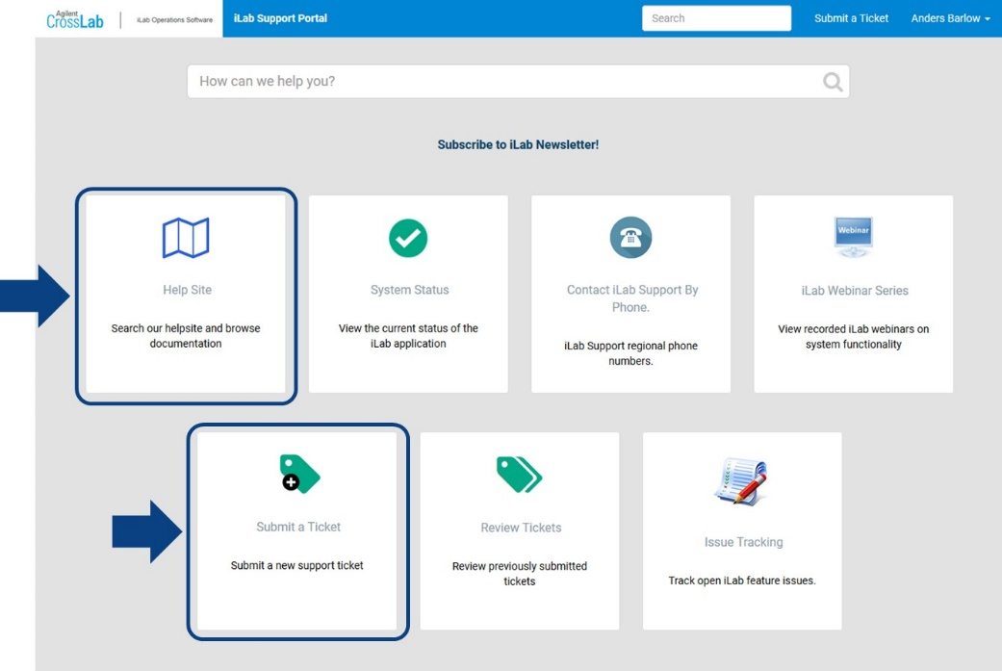

In the iLab support portal you can view the Help Site, which provides comprehensive documentation on the operation of iLab from an end-user perspective (see Using a Core).

Here you can submit a support ticket to Agilent for help with technical issues that could not be resolved locally. Please exhaust local support first before contacting Agilent for support as many issues will likely either be known about or have solutions already that local support can resolve.



Melbourne Histology Platform general enquiries: biomedsci-histology@unimelb.edu.au