

—

**Research Platform Booking System**

Quick Reference Guide

iLab

For researchers

14 September 2020

Table of Contents

Register for an iLab account 3

Register for a UoM account 4

Register for an External account 5

Register for an account from an institution already integrated with iLab 8

Sign-in to iLab 9

UoM Single Sign On (SSO) 10

External Sign In 10

Requesting Access to Multiple Lab Groups 11

Navigating UoM Research Platform iLab Cores 12

Navigating UoM Research Platform iLab Cores 13

Scheduling a Platform Resource 14

The Schedule Equipment Tab 15

Request Training on a Resource 15

Schedule time on a resource 15

Amending reservations 19

Requesting a Platform Service 20

The Request Services Tab 21

Initiating a Request to the Platform 22

The View My Requests Tab 23

Support 24

Support 25

Access the iLab Support Portal 25

Register for an iLab account

Register for a UoM account

Register for an External account

Register for an account from an institution already integrated with iLab

## Register for a UoM account

If you are a University of Melbourne researcher, to get started you must register for an internal UoM account:

Navigate to either the University iLab page or the Research Platform’s Core page:  
https://unimelb.ilab.agilent.com/

1. Hover over the word ‘Register’ and select the ‘**Register using UoM credentials**’ option

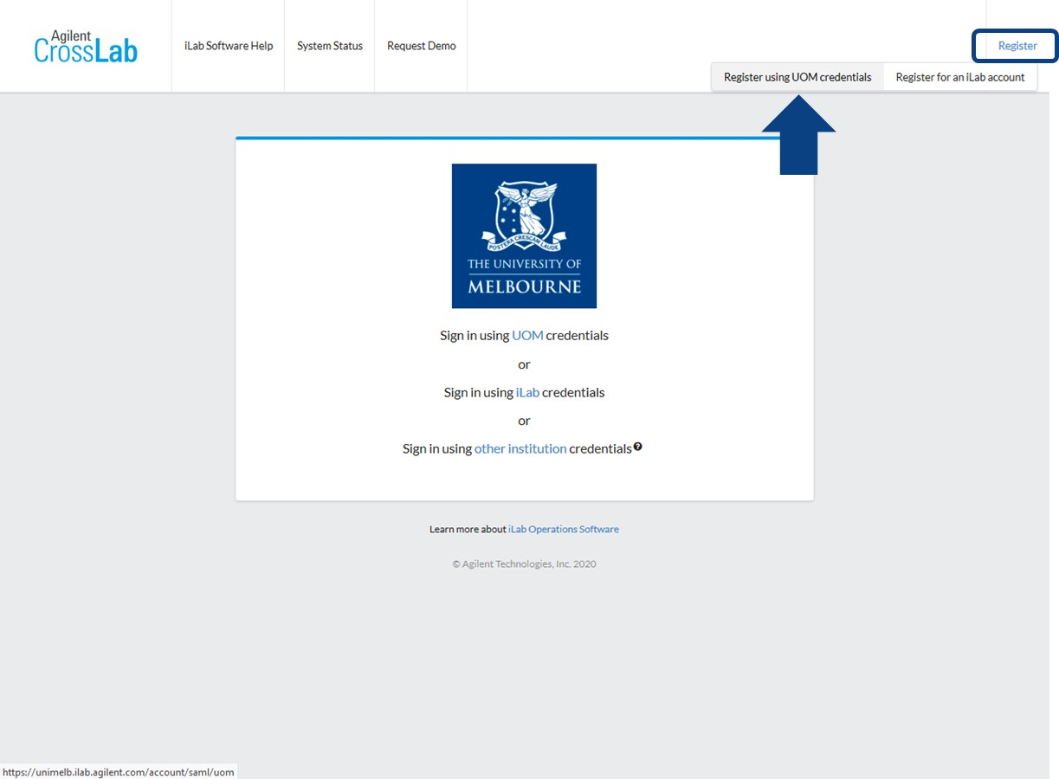

1. You will be directed to the Single Sign On (SSO) page

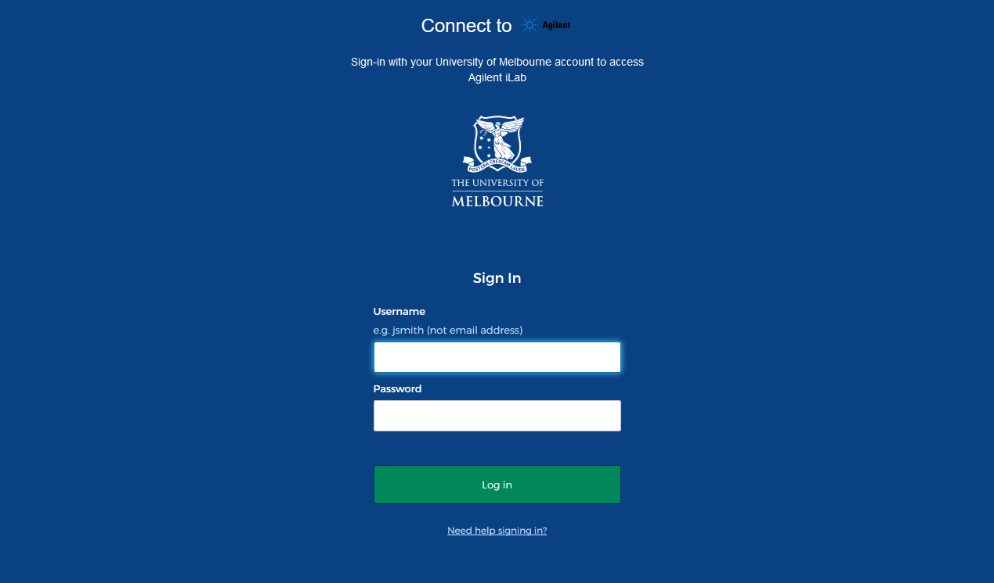

1. Enter your credentials and click the ‘**Login**’ button

You will be directed to an iLab Registration page

1. Select your PI/Lab and verify your contact information.

Once your registration has been submitted, your PI will receive a notification that you have requested membership to their lab in iLab. They will need to approve your membership and assign UoM Themis Code(s) for your use.

## Register for an External account

If you are a researcher that is external to the University of Melbourne (and not from an institution that already has iLab implemented, such as Monash University), to get started you must register for an external iLab account:

Navigate to either the University iLab page or the Research Platform’s Core page:  
https://unimelb.ilab.agilent.com/

1. Hover over the word ‘Register’ and select the ‘**Register for an iLab account**’ option

You will be presented with a multi-step registration form to complete.

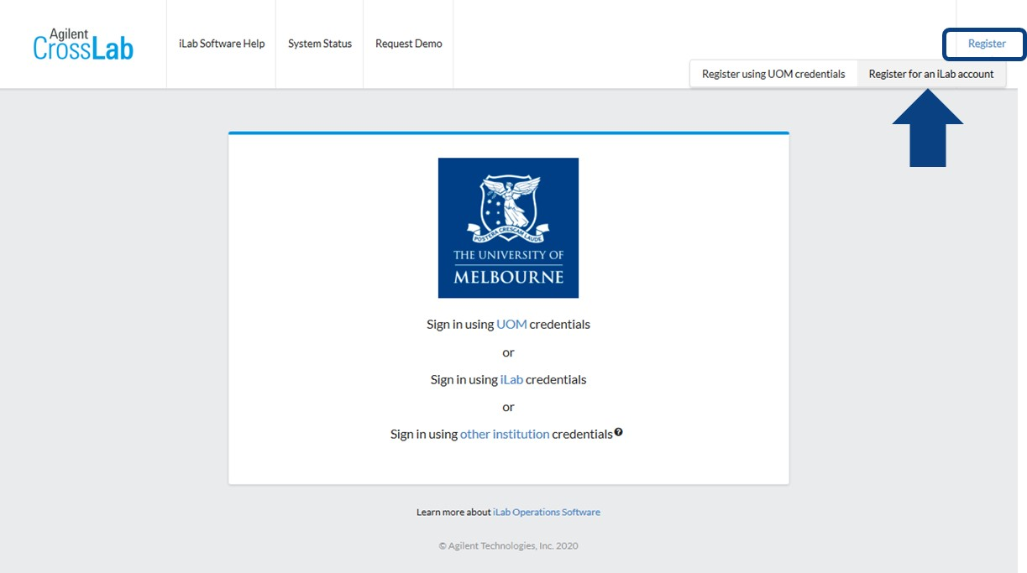

1. Enter your institution email address and click ‘**Continue**’.

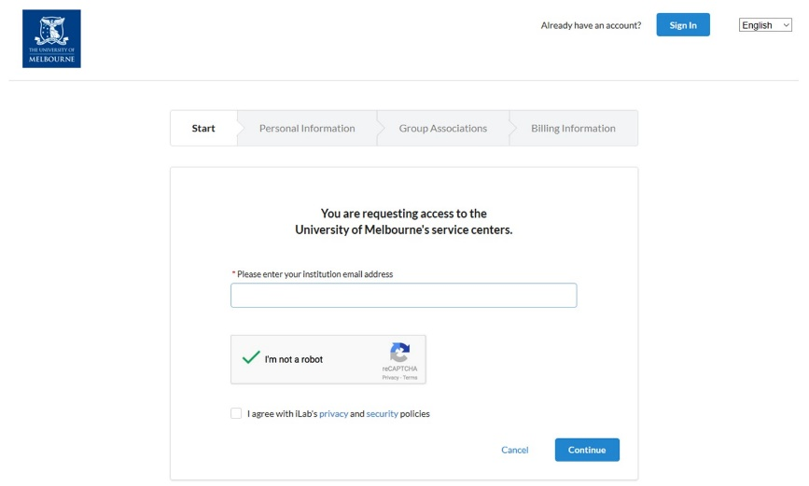

1. Complete the mandatory fields indicated by a red asterisk and click ‘**Continue**’

If your affiliation does not exist for selection, enter the full correct name of your institution/workplace and select the ‘create new’ option.

Example:

* University of Melbourne
  + UoM
  + Melbourne University

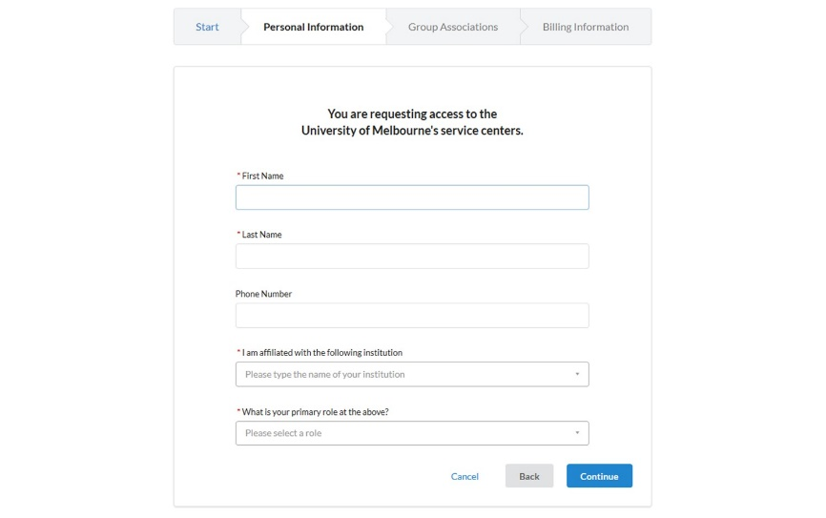

1. Search for your lab group or supervisor name and click ‘**Continue**’

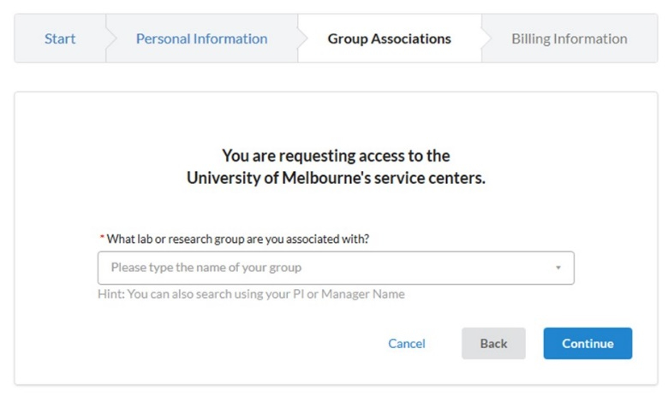

1. If your lab group or supervisor is not available for section, select the ‘**Create New Group**’ option.
2. Complete the mandatory fields indicated by a red asterisk and click ‘**Continue**’.  
   Do not change the auto-generated group name.

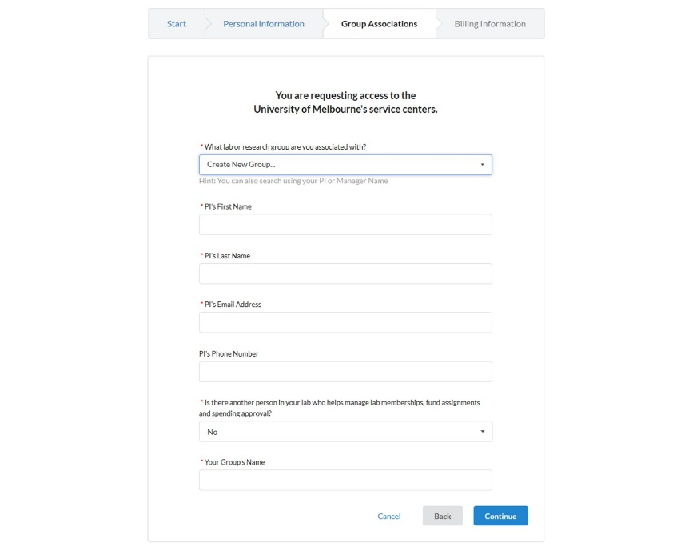

1. Enter the billing address for your institution. Add extra fields to the form, such as Institution and Department, by clicking the prompts on the right side of the form.

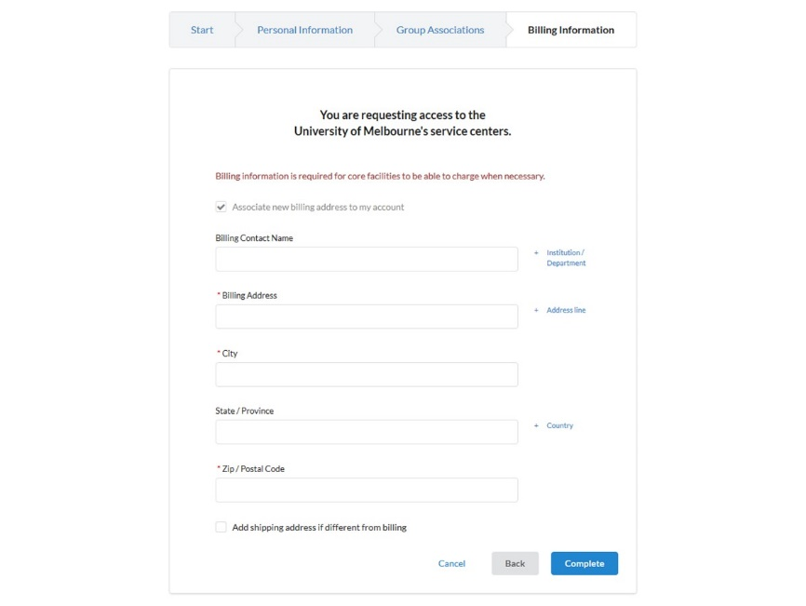

1. Click ‘**Complete’**

Allow 2 business days for your account to be created. You will receive a Welcome Email from iLab with your login credentials.

## Register for an account from an institution already integrated with iLab

If you are a researcher from an institution that is external to the University of Melbourne but that already has iLab implemented, such as Monash University, to get started you must register for an iLab account through your institution’s sign in page.

Navigate either to your institution’s iLab page or the Research Platform’s Core page:  
https://unimelb.ilab.agilent.com/

1. Hover over the word ‘Register’ and select the ‘Register for an iLab account’ option



1. Enter your institution email address into the registration form that appears and click ‘**Continue’**

A pop-up will appear informing you that your institution is already integrated with iLab.

1. Click ‘**Continue**’

Your browser will be redirected to your institutions iLab sign-in page

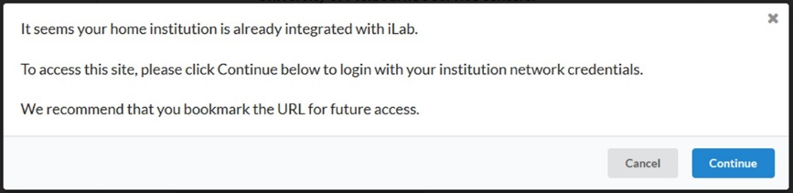

1. Follow your institution’s registration
2. For support please contact your local iLab integration or IT support team

Sign-in to iLab

UoM Single Sign On (SSO)

External Sign In

Requesting Access to Multiple Lab Groups

## UoM Single Sign On (SSO)

University of Melbourne researchers can sign-in to iLab via the UoM SSO portal.

1. Navigate to the Research Platform’s Core page,
2. On the upper-right-hand corner of the screen click ‘**Sign In**’

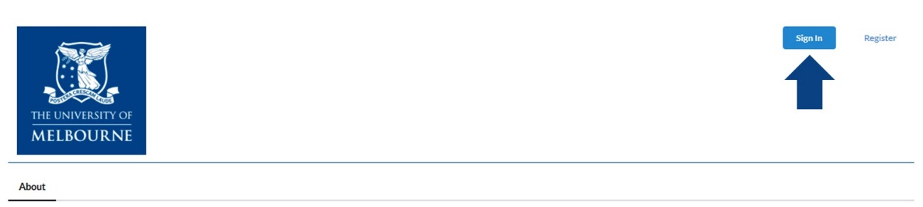

1. Click ‘**Sign in using UOM credentials**’

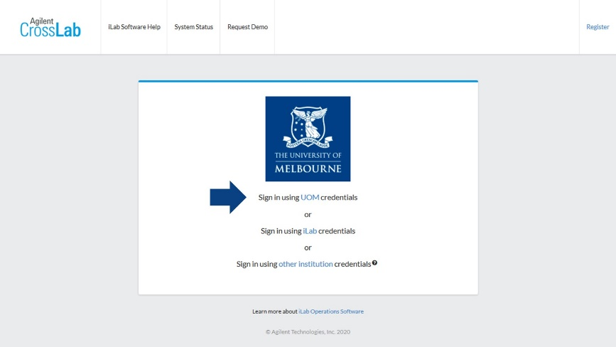

1. You will be taken to the University’s SSO portal to input your credentials. Note that multi-factor authentication (MFA) is also active so you may be prompted to also authenticate via Okta

## External Sign In

**External researchers from an institution *with* an iLab integration** will sign in via their institution login page.

Navigate to the Research Platform’s Core page,

1. Click ‘**Sign in using other institution credentials**’

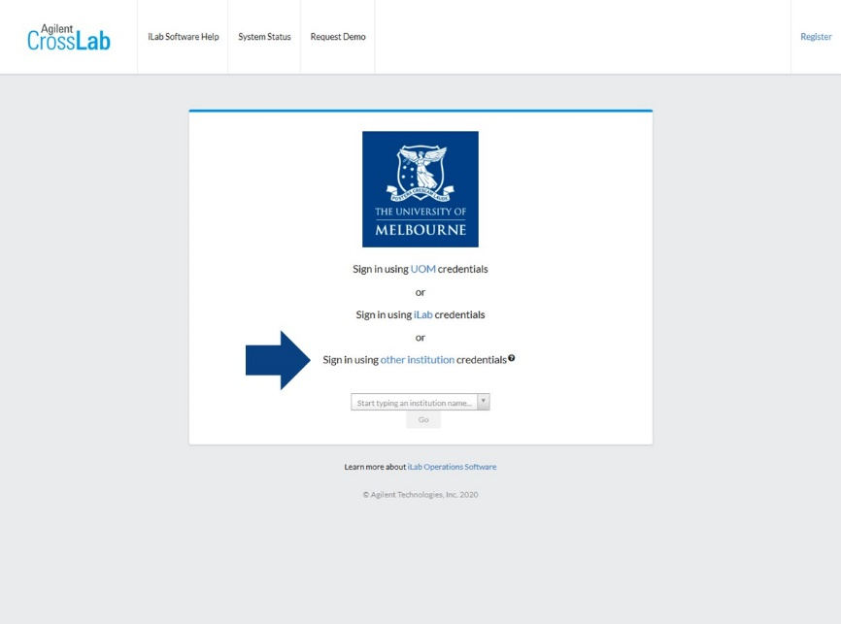

1. In the new field that appears start typing your institution name and select it when it is found.
2. Click ‘**Go**’ and you will be redirected to your institution’s iLab sign-on page
3. When you sign in through your institution you will be redirected back to the UoM Research Platform’s Core

**External researchers from an institution *without* iLab integration** should sign in with their iLab credentials.

Navigate to the Research Platform’s Core page,

1. On the upper-right-hand corner of the screen click ‘**Sign In**’



1. Click ‘**Sign in using iLab credentials**’ and input your login details

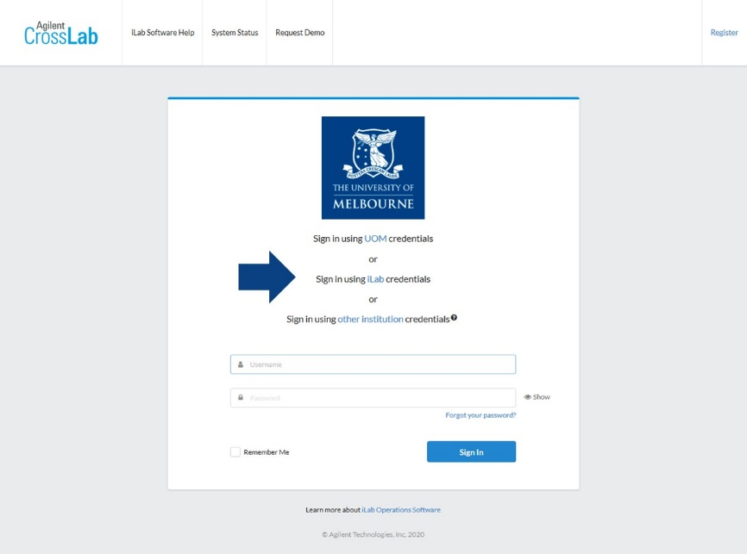

## Requesting Access to Multiple Lab Groups

Researchers in iLab can be members of multiple lab groups. When you register for the first time you will have requested access to your primary lab group. Once you are registered you can then request access to further groups.

Navigate to your institution iLab page and sign-in using one of the above methods,

1. Once signed in, click on the upper-left-hand pop-out menu, then click ‘**Manage Groups**’
2. On the new page click ‘**Request Group Access**’
3. On the new pop-up window search for the institution to which the lab group belongs,  
   for example “University of Melbourne”, and select it
4. In the next box search for the lab group by the name of the group PI using the format “Surname, First Name” and select it when you find the correct lab group
   1. Note, if you cannot find the lab group via the search, you can ask the PI to add you directly
5. Click ‘**Request Access**’
6. The group PI will receive the request and approve your access into their lab group

Navigating UoM Research Platform iLab Cores

## Navigating UoM Research Platform iLab Cores

Agilent iLab has a consistent general appearance across all UoM Research Platforms with most end-user operations accessed via the row of tabs near the top of the page.

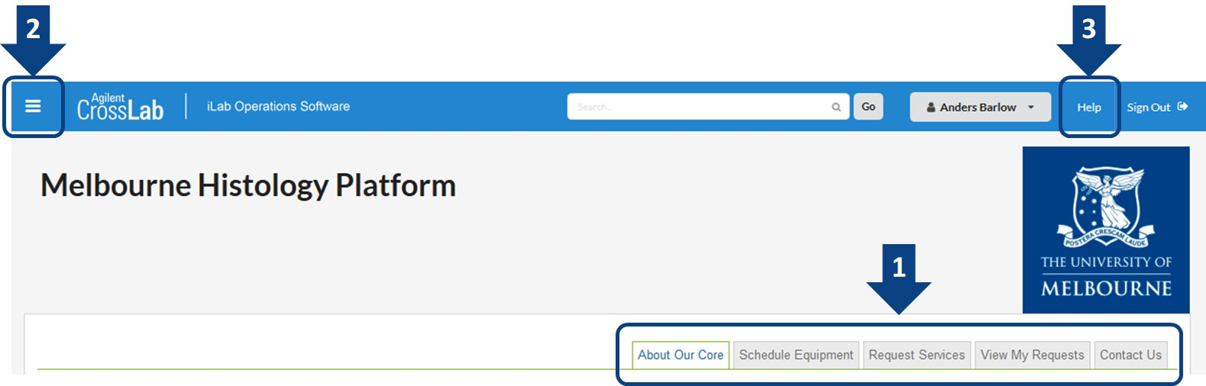

**1 – Navigation tabs**

* **About Our Core** – An overview of the platform’s research capability, services and resources, as well as contact information for the platform leadership and staff
* **Schedule Equipment** – Access the research platform’s resources including requesting training on specific resources, viewing resource schedules and booking time on permitted resources
* **Request Services** – Access the research platform’s services including general service/training requests, and specific services offered by the platform
* **View My Requests** – View requests that you have already submitted to the platform
* **Contact Us** – Submit a comment or question to the platform staff

**2 – ‘Hamburger icon’ left-hand pop-out menu**

* **Home** – Access service requests, messages, your cores and institutions, and all features available in the left and top navigation panels
* **Core Facilities‍** – List and search all core facilities‍ at your own institution, as well as at partner institutions and other outside institutions
* **My Groups** – Manage your group access and request access to new lab groups

**3 – Help**

* Access to iLab's support dashboard which provides help documentation, webinars, and access to the support portal to submit support tickets with Agilent (the system vendor)

Scheduling a Platform Resource

The Schedule Equipment Tab

Request Training on a Resource

Schedule time on a resource

Amending reservations

## The Schedule Equipment Tab

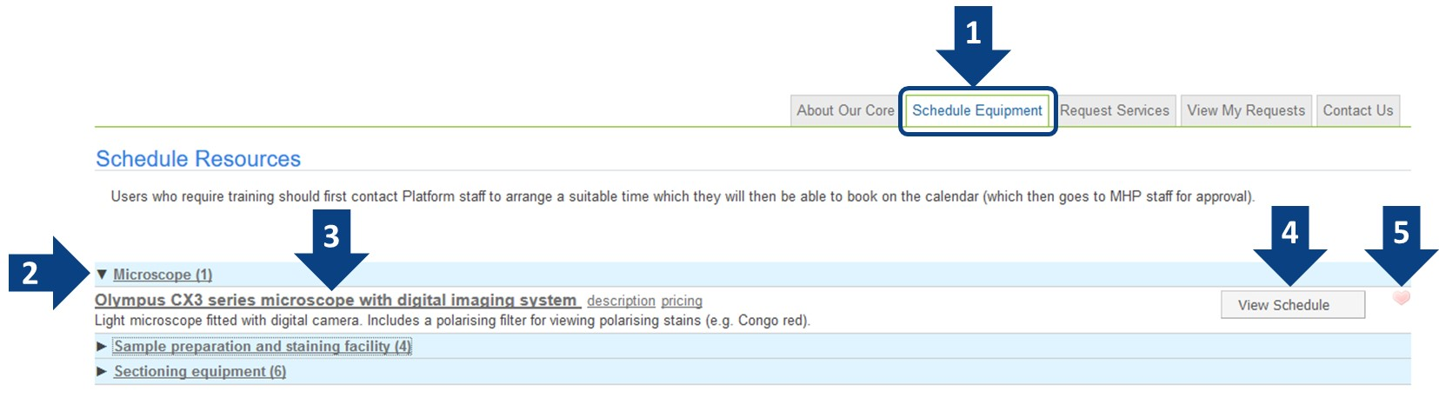

1. Click on the ‘**Schedule Equipment’** tab to view the resources available on the platform
2. Schedules may be categorised in expandable groups, if so, expand the group to find the desired resource
3. **Each resource will have a clickable header name** that will take you directly to the schedule. Beneath this header will be a short description of the resource. Here you can also look at an overview of the pricing for the resource by clicking the ‘**pricing**’ link to the right of the resource header
4. **View Schedule** will allow you to view the schedule for the resource just the same as clicking the header. For some platforms you may also see a ‘Request Training’ button here to allow a direct training request
5. You may designate favourite resources for quick access later by clicking the **heart icon**

## Request Training on a Resource

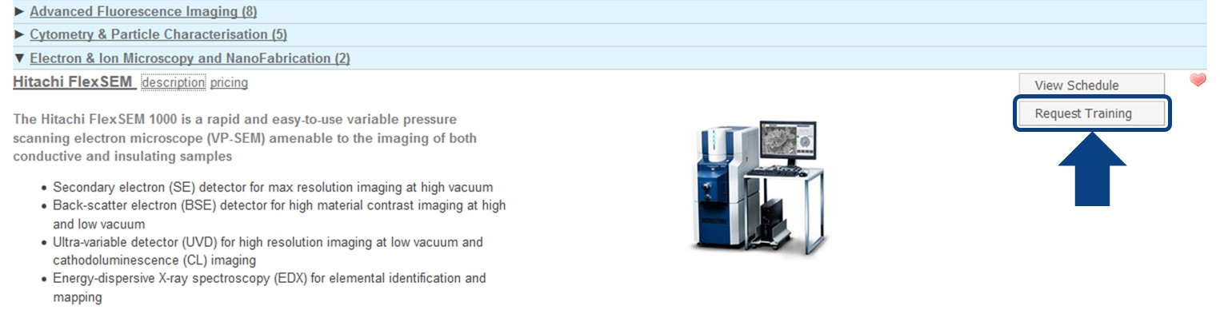

Some platforms may have their resources configured to provide a ‘**Request Training**’ button to the right of the resource description in the Schedule Equipment tab. Clicking this button will take you directly to the necessary training request form for that resource.

The content in this form will vary for each platform but typically you will need to provide information about

* your research and the way you wish to use the resource,
* details about your samples and any hazards that may exist with your work,
* financial details such as the account code this training should be charged against,
* and some forms may give you an indicative cost of the training for you to agree.

Platforms may also only enable training requests for resources to be submitted via the ‘Request Services’ tab. For more details on this tab and how to submit service requests please jump to the next section in this guide.

## Schedule time on a resource

1. Click on the ‘**Schedule Equipment tab**’
2. Navigate to the resource you wish to schedule (you may need to expand the categories in the list), then click on either the resource name or the ‘**View Schedule**’ button to the right
   1. If you see the message below you do not have permission to book the resource, contact the platform manager to enquire about training/induction to access the resource



1. You should now see the calendar for the resource
   1. A schedule will show the current activity colour-coded on the resource including Unavailable times due to maintenance/downtime, your bookings and other researcher bookings (you may or may not be able to see the owner(s) of other booked times)

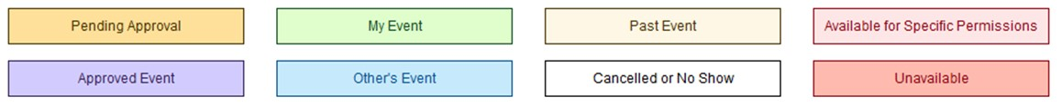

* 1. Near the top-left you can change the display of the schedule and select a specific date, at the  
     top-middle you can skip left and right on the schedule to change days/weeks being viewed

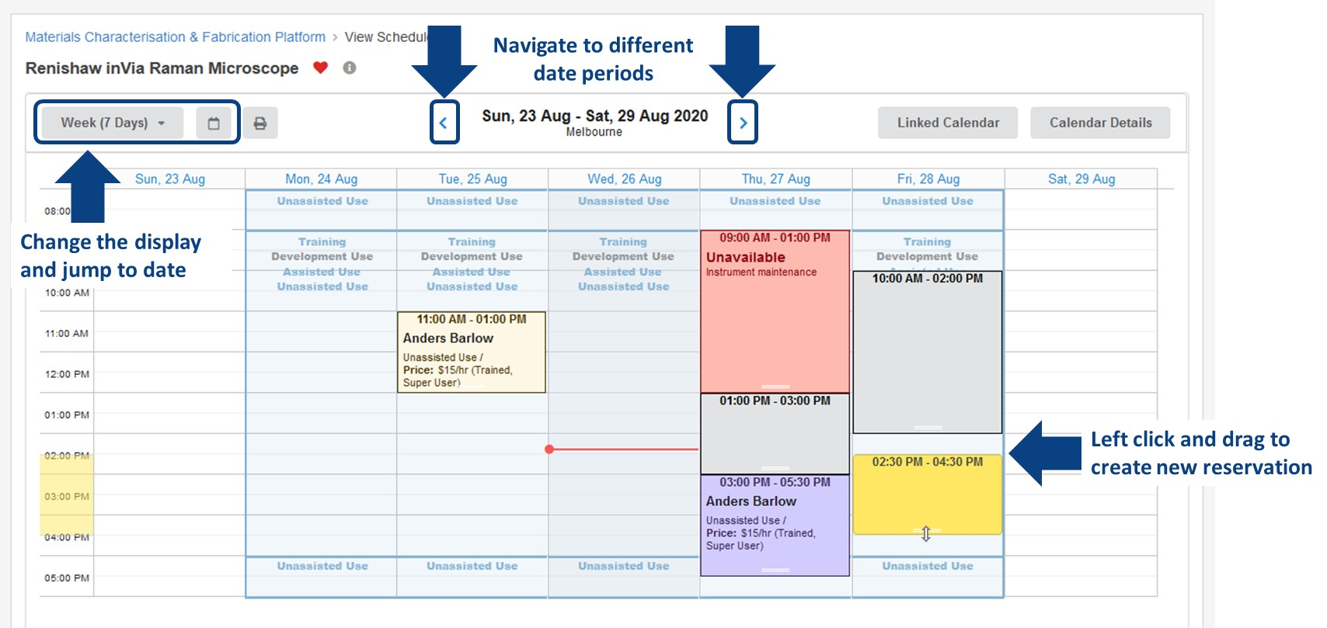

1. To create a new booking, left click on the time/day that you wish to book and that is available, then drag down to create a booking of the desired length of time
2. If you are a member of multiple labs within iLab, you will be prompted to select the lab to which the work will be assigned against, pull down the list and select the correct lab, then click ‘**Next**’

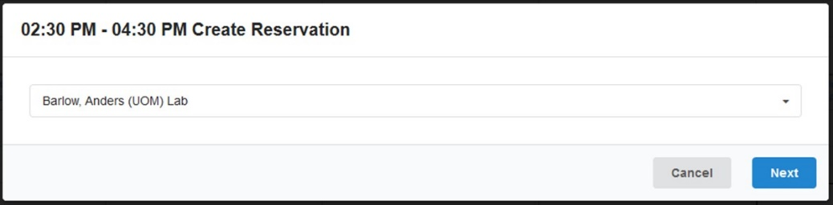

1. A new window will appear with details about your reservation for you to enter and confirm

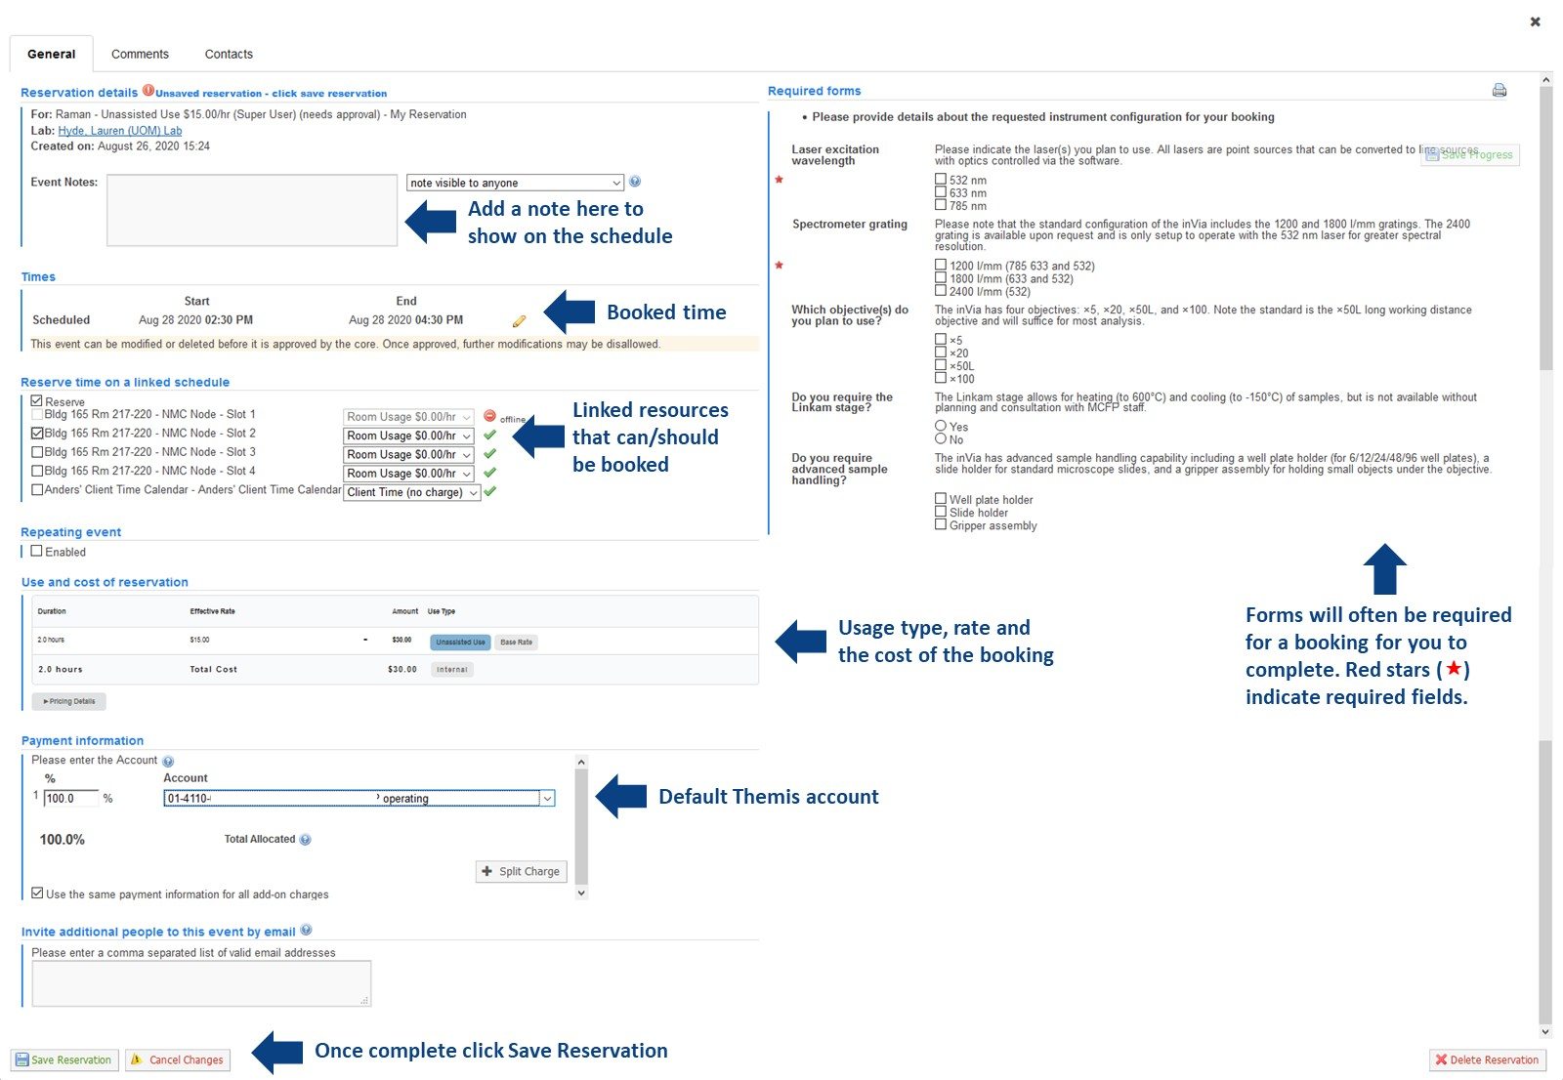

1. Shown above is an example of a reservation window in iLab, you will likely need to scroll to see all the information presented to you in the window
   1. **Reservation details** – Display of the resource, the usage type and rate and the lab under which you are creating this reservation. An Event Note could be added to display on the schedule for either all users to see or only yourself and platform staff to see
   2. **Times** – The scheduled time of the reservation. If the schedule time needs to be amended, click the yellow pencil icon and then save the adjusted times (see Amending Reservations below)
   3. **Linked schedules (platform dependent)** – Some resources may be linked together meaning that you can, or sometimes need to, book time on the linked schedule, here you can make these selections
   4. **Use and cost of reservation** – Usage type that you are allowed to access and the corresponding rate for the resource. The total cost of the reservation is automatically calculated, if you have access to multiple usage types you can select this by clicking ‘Pricing Details’
   5. **Payment information** – Assigned Themis account string(s) available for you to use, these are set by your lab PI and are required to allow the reservation to be made, if no payment information is set please contact your lab PI to organise this
      1. You can also click ‘Split Charge’ to assign multiple Themis strings to split the charge across
   6. **Required forms (platform dependent)** – Each platform will manage this differently, but it will be common to see a form on the reservation screen for you to complete to detail the way in which you plan to use the resource. Some of these questions may require completion to save the reservation
   7. **Save Reservation** – Once you have reviewed and completed the necessary information, click the ‘Save Reservation’ button to submit this to the platform, your reservation may require approval by platform staff before you can use the resource at the scheduled time so wait for a confirmation email from iLab

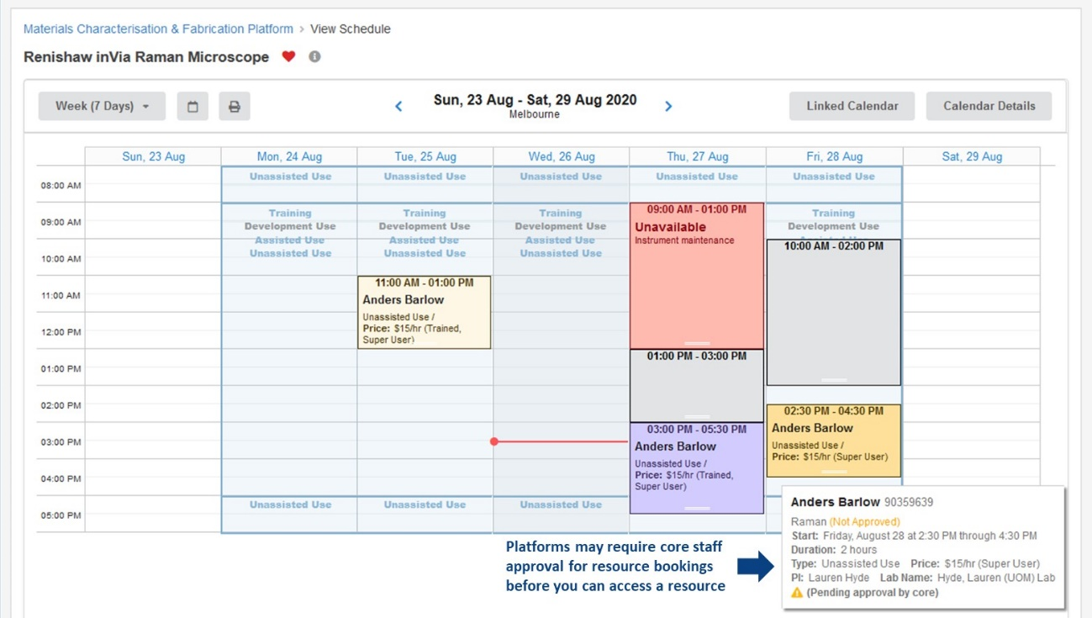

1. When the reservation is saved, you will be returned to the resource schedule where you will see your reservation at the chosen time
   1. If the platform requires reservations to be approved by staff before you can access the resource, you will see that your reservation is indicated as ‘Not Approved’ when you hover over your reservation. You will need to wait for a confirmation email from iLab that the platform staff have approved the reservation

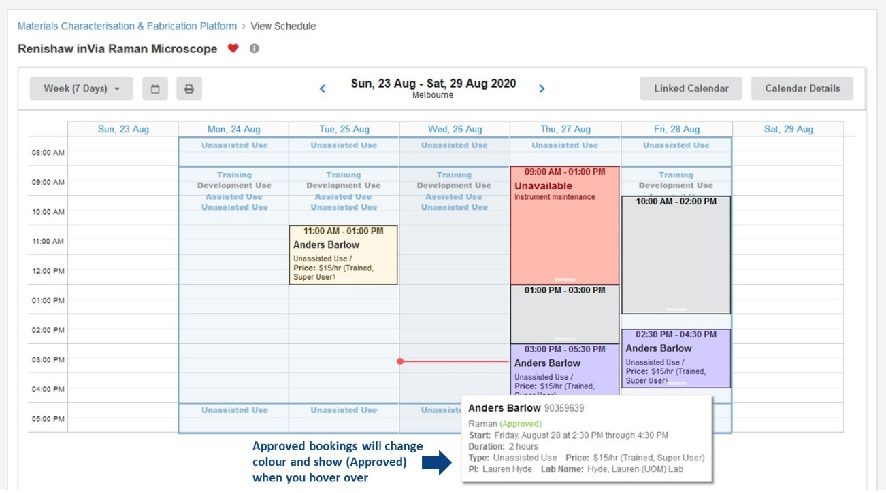

1. When your reservation is approved by platform staff, or if reservations do not require approval, you will see your reservation on the schedule in purple noted as ‘Approved’ and you can now follow the requirements of the platform to access the reserved resource

## Amending reservations

Depending on the way in which a platform manages their iLab Core, you may be able to amend a future reservation, such as changing the reservation date/time or the length of the reservation and alter financial information.  
**Note: once a reservation is approved you may not be able to alter a reservation without contacting platform staff.**

If you need to shift a reservation to another day, earlier or later in the same day, or change the reservation length, with all other details the same, you can drag-and-drop the reservation directly on the schedule.

1. Navigate to the resource schedule and locate the reservation you wish to shift

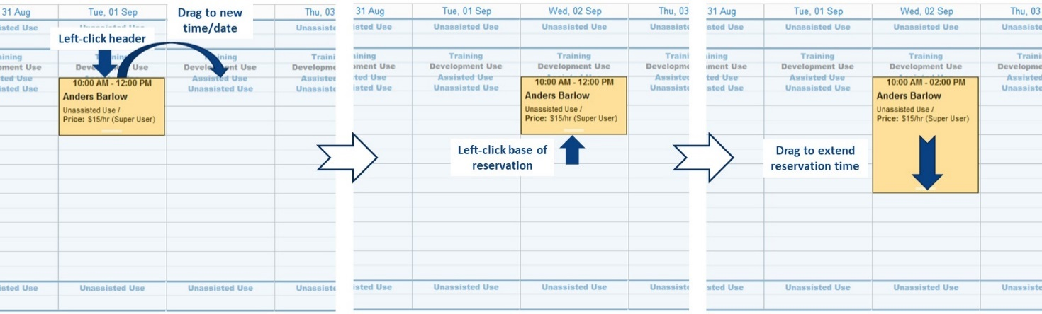

1. Click on the reservation header and drag the reservation to a new time or date
2. To extend or shorten a reservation, click the bottom of the reservation and drag the reservation to the desired length of time

Reservations can be edited directly if you need to perform more precise changes.

1. Navigate to the resource schedule and locate the reservation you wish to amend
2. Double-click on the reservation

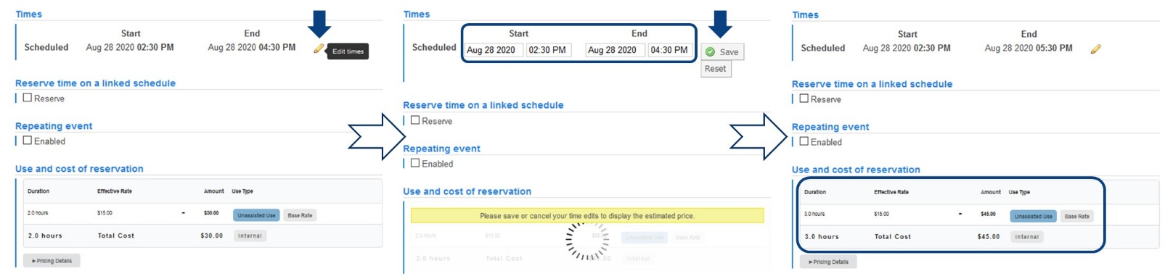

1. To alter the reservation time:
   1. Click on the yellow pencil to the right of the scheduled times
   2. Change the date and/or the required start and end times
   3. Click the ‘Save’ button
   4. The Use and Cost of reservation section and the Total Cost will update after the scheduled time has been edited
2. To change financial information, select the alternate Themis code from the pull-down menu
3. Click ‘Save Reservation’ when you have finished your amendments

Requesting a Platform Service

The Request Services Tab

Initiating a Request to the Platform

The View My Requests Tab

## The Request Services Tab

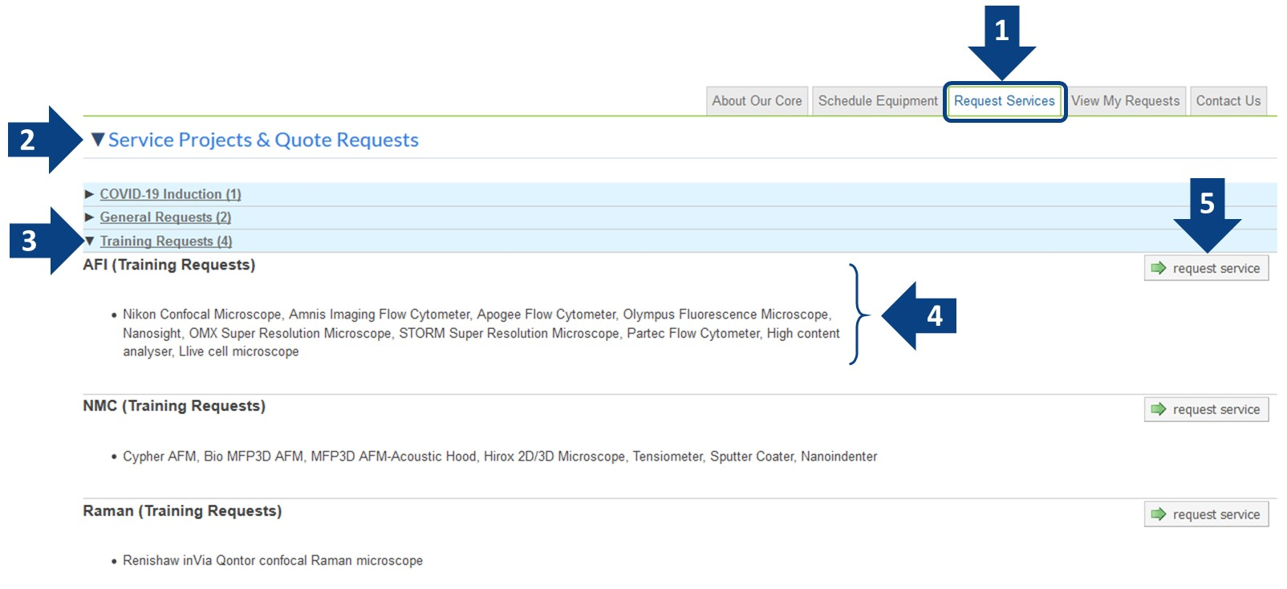

1. Click on the ‘Request Services’ tab to view the services available on the platform
2. The Request Services tab is separated into two sections: Service Projects and Services, most ‘services’ that you would typically request from a platform will be located in the top section (note that some platforms may rename these sections, but they will always be in the same position on the page)
3. Services may be categorised in expandable groups, if so, expand the group to find the desired service
4. Services will be labelled by a header and may have a short description detailing what the service will provide to you by the platform
5. The **Request Service** button will allow you to initiate a request for the service and take you to a form for you to complete

## Initiating a Request to the Platform

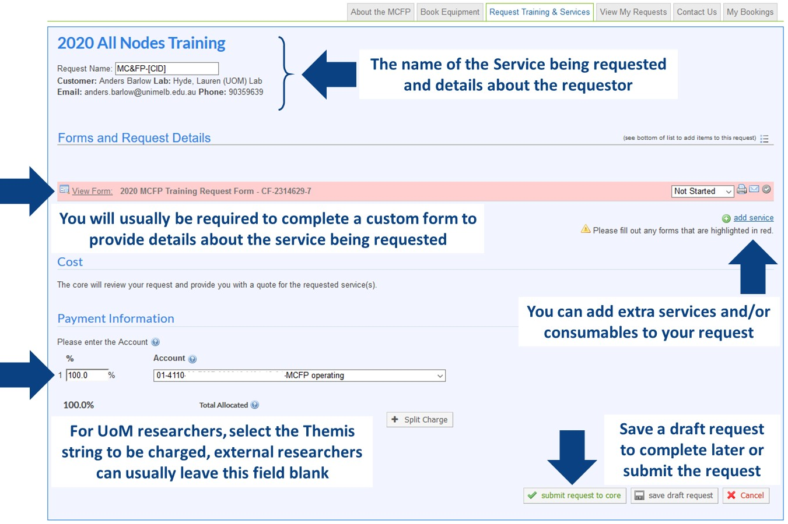  
  
The specific details within service requests will vary between platforms since each platform has specialised capabilities, however the general workflow will remain same between each platform’s iLab Core.

* + - 1. Navigate to the Request Services tab (remember that some Platforms may have renamed this tab), locate the service you wish to request from the platform, and click the ‘Request Service’ button to the right
      2. You will be presented with a new request window that is customised for the service you have requested
      3. At the top of the request you will see your details and your labs details
      4. In the ‘Forms and Request Details’ section you will have one or more forms that you will need to complete in order to submit the request. Forms will ask you to provide specific details about the service you are requesting (such as details about a requested analysis, or how many and what type of samples you will be providing). Some forms may ask you to upload training, induction or OHS documentation to the platform to allow them to process your request. Mandatory fields in forms will be marked with a red star (****)
      5. In some cases, you may need to add extra services into a request, such as lab consumables, and the ‘Add Service’ link on the right side allows you to add these extra services into your request
      6. Depending on how the platform has configured the request the Cost section may not display any estimated costs until after the request has been reviewed by the staff
      7. The Payment Information section will allow internal UoM researchers to select their appropriate Themis account string to charge the request to, while for external researchers this section will allow the researcher to enter payment information such as a purchase order number (if required by the platform)
      8. Finally, the service can be requested by clicking ‘Submit Request to Core’, or can be saved as a draft to be completed later

## The View My Requests Tab

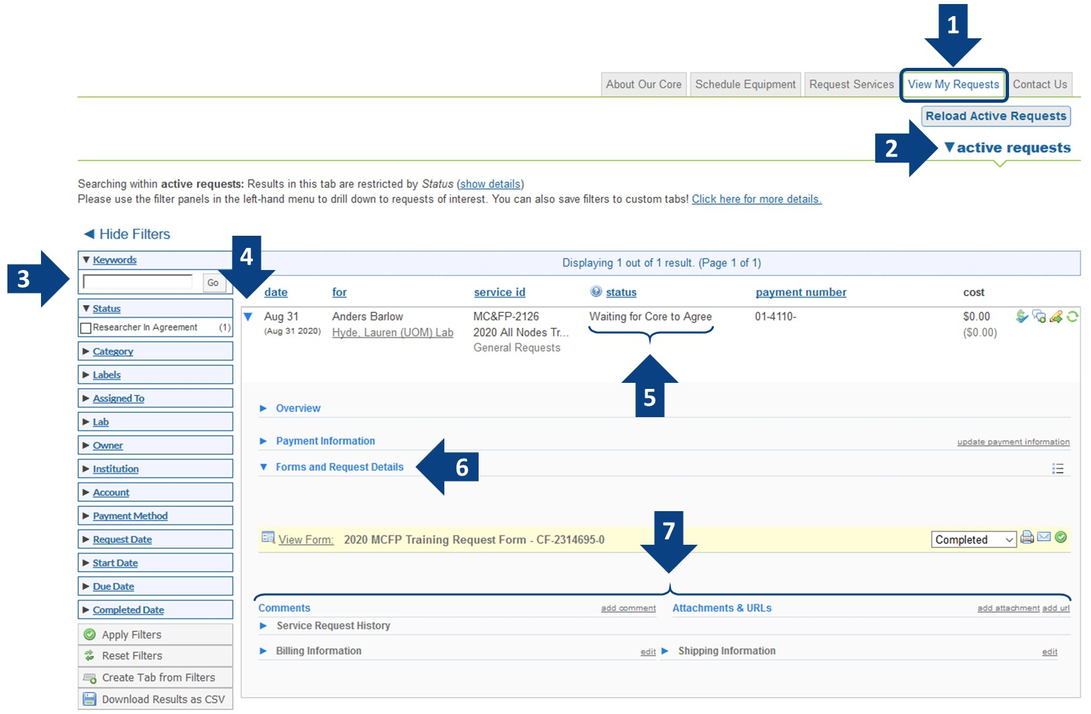

Once you have submitted a request to a research platform you will see your request appear in the ‘View My Requests’ tab which will allow you to keep track of your requests

1. Click on the ‘View My Requests’ tab where you will see a list of the requests you have made across all iLab Cores you access, including those not at a UoM research platform
2. You can display only active requests, i.e. requests that require action on part of the researcher or the Core, or requests in various other states (all requests, completed, cancelled, processing etc..)
3. You can filter the list of requests with the left-hand panel, including by searching using a keyword, or filtering by Status, Category or Date
4. To inspect a request further, click on the drop-down triangle to the left of the request which will expand the request and give you access to all the details
5. The status of the request is indicated for each request, common statuses are:
   * *Waiting to Submit to Core* – a draft request that you have not yet submitted
   * *Waiting for Core to Agree* – a request that has been submitted to the Core and is awaiting approval
   * *Waiting for Researcher to Agree* – a request that has either been made on your behalf and is waiting for you to agree to it, or one that has had financial details updated and requires your approval
   * *Waiting for Core to Begin* – a request that has been agreed upon by all parties and is ready to start
   * *Processing* – a request that has been started by the Core
   * *Complete* – a request that has been marked as completed by the Core and is ready to be billed
6. Forms associated with the request can be viewed and amended here
7. Other details related to the request are near the bottom and include the request history and any attachments that have been added to the request such as quotes, documentation, or data files

Support

## Support

**For UoM SSO login issues**, UoM researchers should contact the IT Service Centre on +61 3 834 40888/40999 or via the University Services Portal.

**For external researcher login issues**, please contact your institution’s IT Support if your institution has an iLab integration, or contact iLab directly at iLab-support@agilent.com if your institution is not on iLab.

**For any resource, service or platform-specific support**, your first contact should be with the platform management staff. Contact information for the platform will generally be included on the ‘About Our Core’ tab.

**For support with financial payment information** or to ensure you have the correct Themis account string attached to your iLab account when you book resources or make service requests, please talk to your supervisor or the PI or financial manager for your lab group.

**For simple or general iLab support** and “How do I…?” type questions, talk to platform support staff who will be able to assist you with frequently asked questions.

**For more in-depth iLab support**, read through the Help documentation on the iLab support portal.

## Access the iLab Support Portal

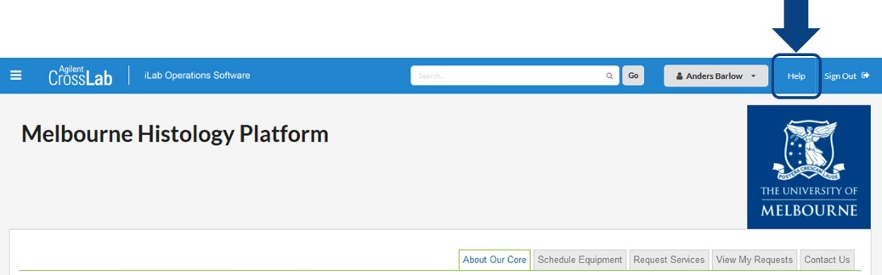

From any core page you will be able to access the iLab Help Portal by clicking the ‘Help’ button in the top-right of the page. This will open the portal in a new window.

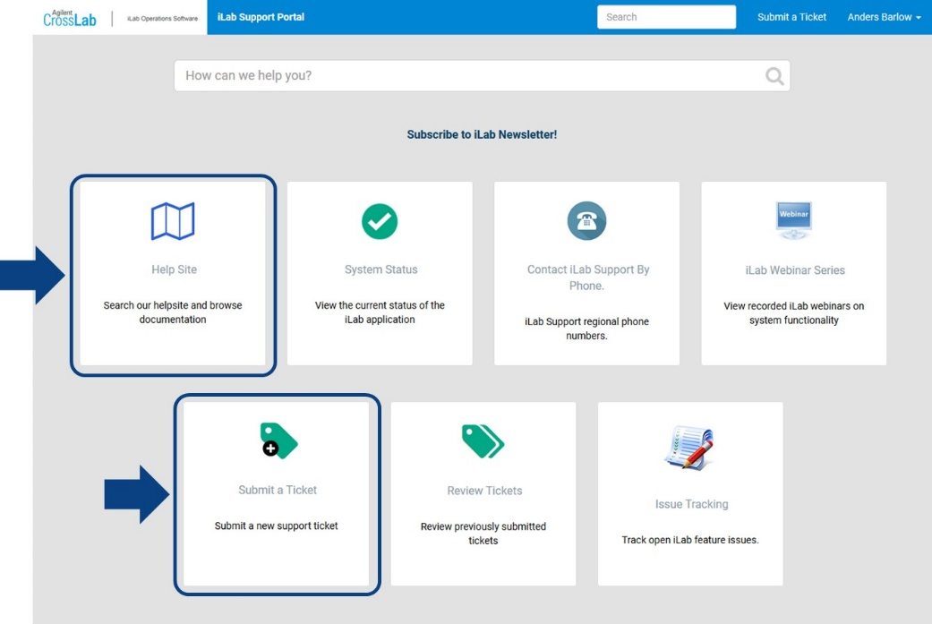

In the iLab support portal you can view the Help Site, which provides comprehensive documentation on the operation of iLab from an end-user perspective (see Using a Core).

Here you can submit a support ticket to Agilent for help with technical issues that could not be resolved locally. Please exhaust local support first before contacting Agilent for support as many issues will likely either be known about or have solutions already that local support can resolve.



Melbourne Histology Platform general enquiries: biomedsci-histology@unimelb.edu.au